**HIGHFIELD FARM PRIMARY SCHOOL**

**Computing Policy**

**Date of Policy approval _____________**

**Date of Policy review _______________**



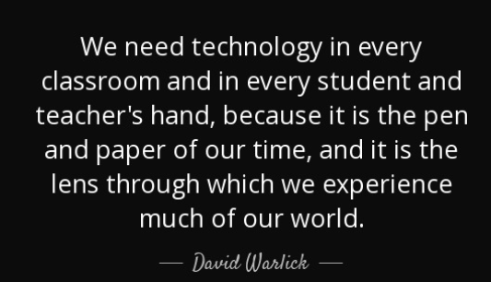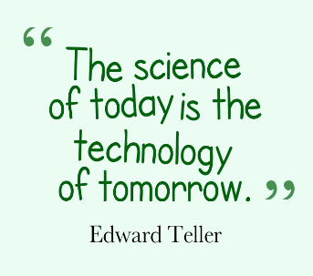

‘The National Centre for Computing Education defines digital literacy as the ‘skills and knowledge required to be an effective, safe and discerning user of a range of computer systems. It covers a range of knowledge and skills, such as using physical devices or knowledge and skills, such as using physical devices or knowledge of the features that are likely to mean digital content is reliable.’ Ofsted’s review of computing.

At Highfield Farm Primary, we understand the importance of introducing our children to the world of computing and how essential it is in society. Our aim is to fulfil the requirements from the National Curriculum for Computing, while enabling children to become computationally literate including teaching the importance of online safety. The world of computing is ever-changing, and it is becoming increasingly crucial that children have a full understanding of the knowledge and skills in all aspects of computing so that they have a better footing within the wider world. Technology will be part of our children’s future; we consider the resilience they need to engage with technologies that do not currently exist.

**Intent**

At Highfield Farm Primary School, we believe fully in developing our children’s understanding of technology and how it must be used in a safe and respectful manner. Our computing curriculum aims to develop the heart and mind of every child. A high-quality computing curriculum, should foster the children’s engagement and development of concepts taught throughout our chosen scheme. By following the National Curriculum for Computing, we aim that all children can:

* understand and apply the fundamental principles and concepts of computer science, including abstraction, logic, algorithms and data representation
* analyse problems in computational terms, and have repeated practical experience of writing computer programs in order to solve such problems
* evaluate and apply information technology, including new or unfamiliar technologies, analytically to solve problems
* be responsible, competent, confident and creative users of information and communication technology

Our carefully crafted curriculum draws upon the Teach Computing curriculum resources. It is designed to provide our children with the subject specific language they need to describe, question and discuss ideas relating to computing and computer science as well as the very specific knowledge they require to become competent and adaptive in an ever changing, technological society. Indeed, it is one of the ‘Specialism’ aspects of the 4-element curriculum model at Highfield Farm Primary School that will add real value to the children’s primary education.

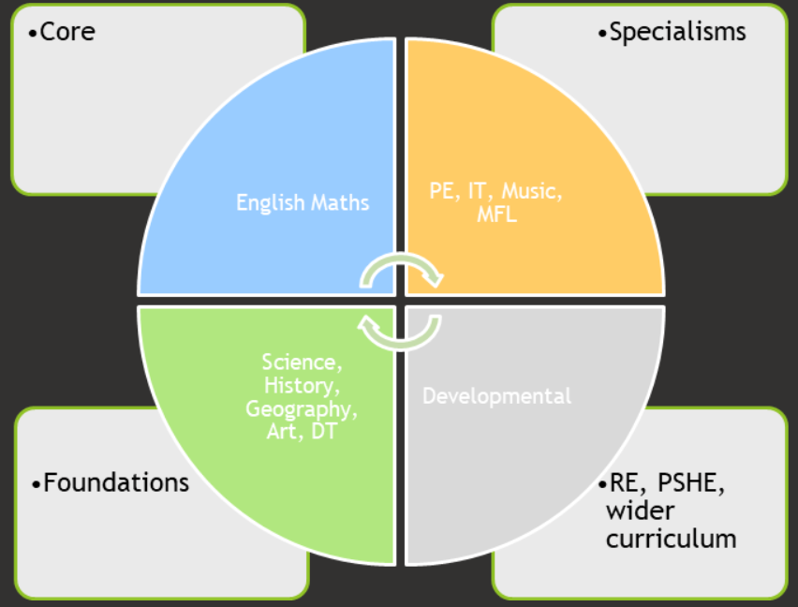

**Implementation**

The Teach Computing Curriculum is a fully aligned, resourced scheme that teaches the depth and breadth of the computing curriculum, particularly beyond programming. It has been chosen as a preferred scheme as it provides us with the bigger context of the subject beyond primary education. Such curriculum knowledge is vital in preparing our children for the next step in the curriculum for computing. Our computing curriculum ensures that the three pillars of progression are addressed and broken further down into themes and taxonomy strands. The Teach Computing curriculum uses the National Centre for Computer Education’s taxonomy to ensure comprehensive coverage of the subject. The curriculum has very specific end points per key stage in the following areas:

**Computer systems**

**Computer networks**

**Programming**

**Algorithms**

**Design & development**

**Data & information**

**Creating media**

**Effective use of tools**

**Impact of technology**

**Safety & security**

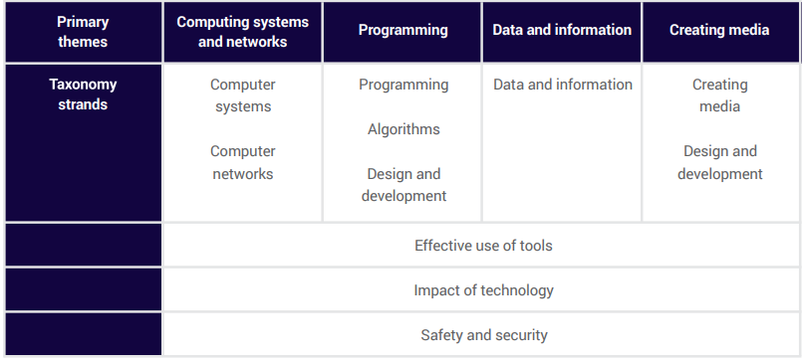

Computing teaching will deliver these requirements through our half-termly units. Our Computing progression model is broken down into three strands that make up the computing curriculum. These are Computer Science, Information Technology and Digital Literacy. Computer Science underlines the knowledge and skills relating to programming, coding, algorithms and computational thinking. Information Technology underlines the knowledge and skills relating to communication, multimedia and data representation and handling. Digital Literacy underlines the knowledge and skills relating to online safety and technology uses all of which are covered combined or discreetly. For an overview of the units, see Appendix 1.

The units for the key stage 1 and 2 are based on a spiral curriculum. This means that each of the themes is revisited regularly (at least once in each year group), and pupils revisit each theme through a new unit that consolidates and builds on prior learning within that theme. This style of curriculum design reduces the amount of knowledge lost through forgetting, as topics are revisited annually. It also ensures that connections are made even if different teachers are teaching the units within a theme in consecutive years.

The Teach Computing scheme provides the theoretical subject knowledge for teachers and pupils as well as the resources needed to teach a highly sequenced, ambitious and inclusive curriculum. The approaches taken for the delivery of lessons covers 12 key principles. The teachers use their professional judgement in reviewing, selecting and applying the principles.

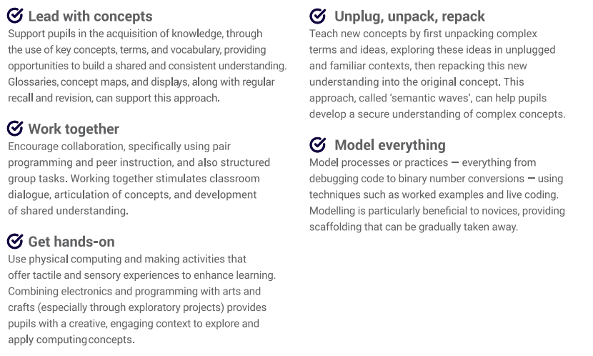

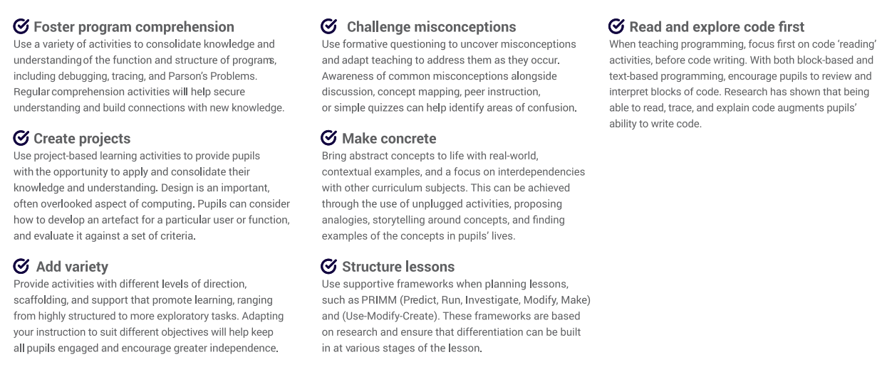

**Organisation**

Due to the make-up of the cohorts at Highfield Farm Primary School, it will be necessary to make annual decisions based on changing cohorts. The curriculum is covered on a two-year cycle. The order in which to teach units within a school year is not prescribed, other than for the two ‘programming’ units for each year group, which build on each other. The units and order of the units are as follows:

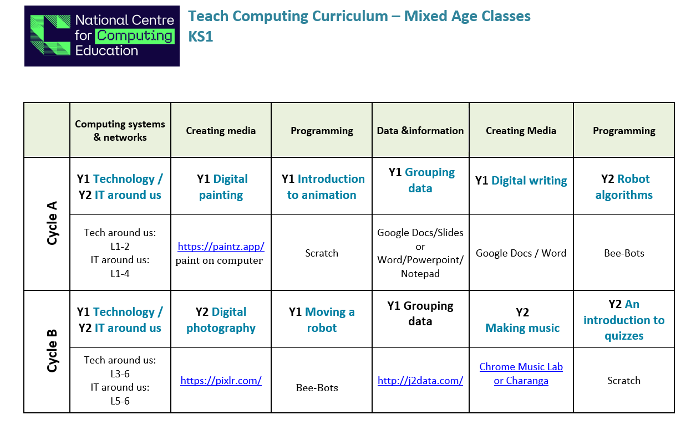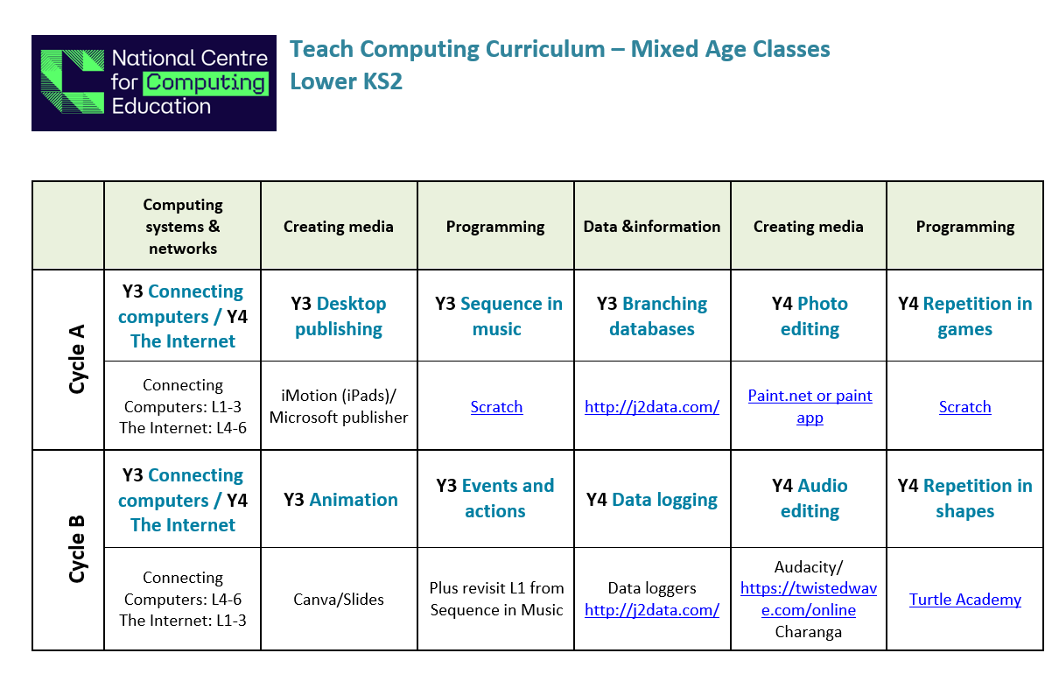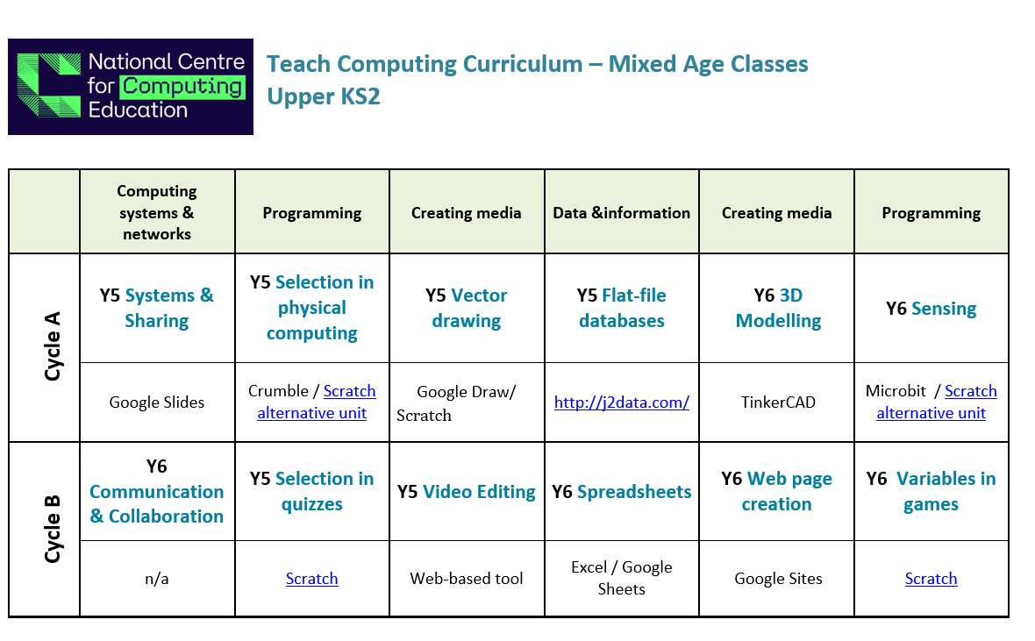

**Planning**

As computing is a specialist subject, and that not all teachers are specialists in computing, all lessons are planned for by the Teach Computing scheme we have adopted in school, so that skills and knowledge can be built on sequentially throughout the children’s time at Highfield Farm Primary. It is the teacher’s responsibility to ensure they have read and understood the planning document before the launch of both individual units and lessons. Each individual lesson has content that is differentiated between, and within, year groups so that learning is age-appropriate and high expectations are maintained. Individual and/or sequences of lessons must take into account the following principles of instruction as laid out by Barak Rosenshine (See Appendix 2).

**Oracy within the curriculum**

At Highfield Farm Primary School, we use oracy as a means to ‘learn to talk’ and ‘talk to learn’. Our staff use strategies to promote talk in lessons which aims at not only developing the children’s ability to talk effectively for a variety of purpose, but also as a means to develop their understanding of the content being taught.

**The importance of vocabulary**

Teachers use questioning, and provide opportunities for discussion and investigation to support the development of specific computing and computer science vocabulary, which is explicitly taught and modelled by teachers in every lesson. Key technical terms and language (such as code, algorithm, debug, etc.) are revisited frequently, to make learning memorable, relevant and easy to retrieve. This is complimented by our vocabulary policy.

The teaching of vocabulary has been specifically designed to also take account of introducing children to specific terminology that will support future learning.

**EYFS**

At Highfield Farm, we aim to provide EYFS children with broad, play-based learning opportunities to:

* use a range of ICT scenarios based on experience in the real world, such as in roleplay.
* gain confidence, control and language skills through opportunities to ‘paint’ on a range of computing devices such as; interactive board and iPads, as well as being able to control remotely operated toys.
* use recording devices to develop their communication and language skills through recording devices.
* follow instructions involving several ideas and actions.

We encourage the use of technology across our children in the nursery and reception classes as an integral part of their work. We guide children to make sense of the physical world and their community through opportunities to explore, observe, and research technology.

**Impact**

Our Computing Curriculum is high quality, well thought out and is planned to demonstrate progression and build on and embed current skills. We focus on progression of knowledge and skills in the different computational components and alike other subjects discreet vocabulary progression also form part of the units of work. If children are keeping up with the curriculum, they are deemed to be making good or better progress.

We measure the impact of our curriculum through the following methods:

* Pupil discussions and interviewing the pupils about their learning (pupil voice)
* Monitoring with our subject computing lead visits
* Opportunities for dialogue between teachers
* A reflection on standards achieved against the planned unit outcomes
* Learning walks and reflective staff feedback (teacher voice)
* Monitoring of children’s work.

**Appendix 1**

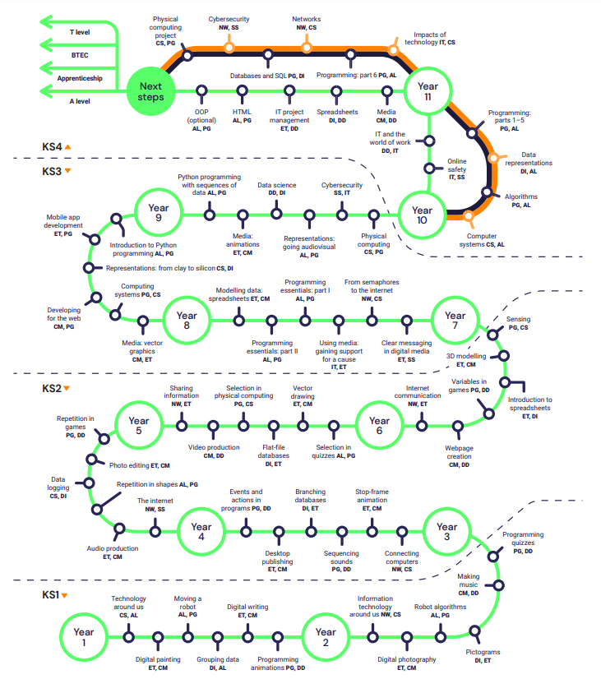

**Appendix 2**

