**HIGHFIELD FARM PRIMARY SCHOOL**

**Science Policy**

**Date of Policy approval _____________**

**Date of Policy review _______________**

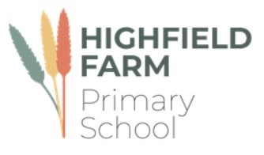

‘The important thing is to never stop questioning’

Albert Einstein

At Highfield Farm Primary School, our philosophy reflects the idea that science is a beautiful subject that should stand in its own right. We take the view that the subject should not be at risk of being watered down with cross curricular or overarching ‘topics’ that may devalue the quality of the subject, although we do recognise that when it is appropriate, cross discipline links are possible which support schema development and long-term memory retention.

**Intent**

As a school, we follow the Primary Knowledge Curriculum (PKC).In doing so, we can guarantee scientific rigor and coverage against the national curriculum. Any many cases, our science offer goes beyond the requirements laid out in the curriculum but designed in a way that overload is mitigated against.

The Primary Knowledge Curriculum aims to enable children to understand the world around them through a scientific lens. In doing so, our adoption of this curriculum seeks to ensure that pupils are well-equipped to go forth into their secondary education and later life with curiosity, passion and a desire for discovery. Pupils will be taught units of work that cover and go beyond the requirements of the National Curriculum. As a result, our pupils gain a deep understanding of science as a unique discipline, constituting of the three strands of biology, chemistry and physics. Alongside this, pupils will also encounter a series of units that develop their understanding of Earth Science, developing their understanding of environment and sustainability. Pupils will build a body of key foundational science knowledge as they work through the curriculum, asking questions and developing a sense of curiosity about the world around us. The curriculum will build disciplinary literacy for pupils, enabling them to communicate scientific understanding through diagrams and written explanations in increasing depth and complexity as they progress through the primary phase. We understand the importance of developing aspirations in science within our children for the betterment of society and, through high-quality teaching and learning, our children will develop a love for the curious nature of science and strive to become scientists in the future.

The Primary Knowledge Curriculum aspires to create curious and knowledgeable young people, who hold a deep understanding and appreciation of the discipline of science. Indeed, it is one of the ‘foundations’ aspects of the curriculum at Highfield Farm Primary School that will add real value to the children’s primary education and later academic study.

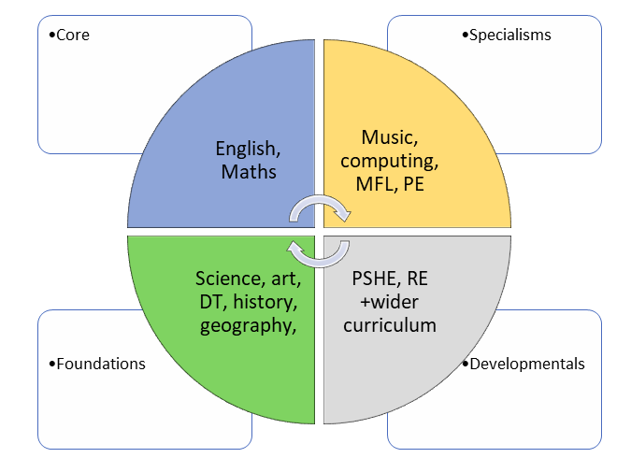

The children of Highfield Farm Primary School have a voice and have the right to use it and so should be encouraged to express their opinions and thoughts. We teach and encourage the use of discussion and debate on a regular basis as a means of children developing and expanding their scientific thinking. Our work on oracy is a golden thread that supports this as it does in other curricular areas. The Primary Knowledge Curriculum will produce well rounded and informed pupils whose cultural capital is expanded and whose skills and knowledge can be applied across the curriculum.

**Implementation**

The Primary Knowledge Curriculum builds knowledge incrementally. Pupils have multiple opportunities to secure and build upon their knowledge by revisiting subject content at carefully sequenced points throughout the curriculum. By building upon their knowledge in a cumulative manner, the curriculum ensures pupils secure greater breadth and depth in their understanding of scientific knowledge, skills and the discipline of science. This progression helps children to master the knowledge and concepts whilst simultaneously building up an extended subject-specific vocabulary that enables them to communicate their knowledge. Pupils will be encouraged to use the knowledge they learn in science and apply it to investigations that test a hypothesis or set out to answer a question. The curriculum builds pupil understanding of disciplinary knowledge over time. Importantly, **substantive scientific knowledge is taught first, before pupils are asked to undertake enquiry**. This helps them to fully understand the elements of the enquiry first, and to make informed observations about the processes they see. Gathering information, recording data, graphing data and interpreting findings are all essential skills that pupils will apply to new contexts as they work through the curriculum. Each of these will develop the pupil’s ability to clearly communicate their scientific understanding.

Disciplinary knowledge is developed through the working scientifically criteria laid out on the lesson plans. To compliment this, pupils will also develop their understanding of the five types of scientific enquiry: **observing over time**; **pattern-seeking**; **identifying**, **classifying and grouping**; **comparative and fair testing**; and **researching using secondary sources**. Scientific enquiries will provide children with a wealth of opportunities to explore what they have learnt. Most importantly, they will help to deepen our pupils’ understanding of the nature, processes and methods of science as a discipline, and how it differs from other subjects they are studying.

**Curriculum Organisation**

Due to the makeup of the cohorts at Highfield Farm Primary School, a creative two-year cycle approach to coverage has been taken. Planning for the themes and topics in the Science curriculum are taken from the medium-term planning documents within the PKC online resources. Cycle A takes into account the lower age group units within a key stage. Cycle B takes into account the higher age group within the key stage. The following table indicates the scientific units that are studied during the children’s Highfield Farm Primary School’s career.

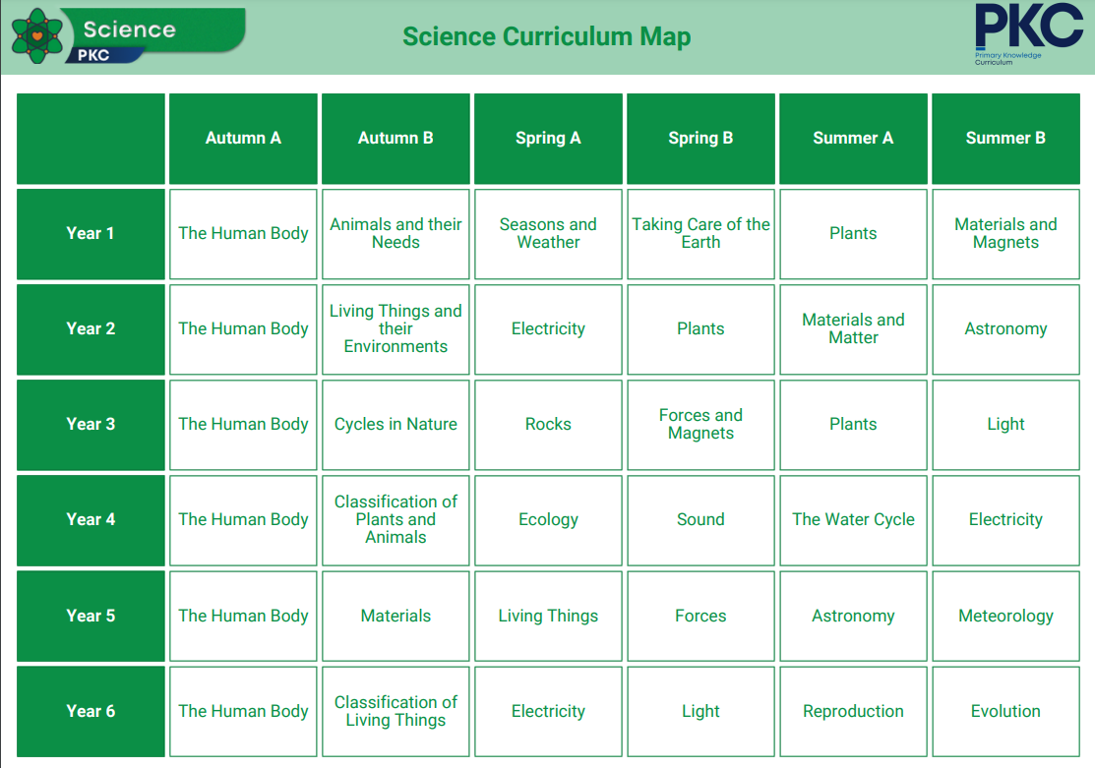

Owing to the importance of science in its own right and in order to minimise the potential for a diluted science curriculum, we have favoured an approach where science is stand alone. However, where links to the wider curriculum can be made, they are acknowledged. The science curriculum could support in providing the background knowledge to an English topic and the driving texts behind them and the vital cultural capital to engage at a deeper level with the text seen within the main English lessons. To this end, all science learning is presented in a separate science text book. This will show very clearly the progression of substantive and disciplinary knowledge as the children move through their primary education at Highfield Farm Primary School.

**Planning**

Planning for science comes from the long-term overview in the cycles as laid out above, and broken down further into thematic scientific units which act as the medium and short term planning. All teachers are responsible for using such planning materials to deliver from and tailor for the needs of the children within their classroom. It is the teacher’s responsibility to break down concepts into relevant **components** and **sequence** them effectively so as not to overload the children’s short-term memories. Each individual lesson has content that is differentiated between, and within year groups so that learning is age-appropriate and high expectations are maintained.

Lesson planning from the PKC materials act as a **starting point** from which to start planning from. If teachers have ideas that they believe will work well, so long as it supports the sequencing of lessons, then they have the autonomy and professional trust to do so.

Individual and/or sequences of lessons must take into account the principles of instruction as laid out by Barak Rosenshine. This will add clarity and simplicity to the teaching and learning process within science. (See Appendix) This is not to say that every principle is to be seen in every single lesson. The purpose of reviewing material is key in ensuring that material becomes stored in the long-term memory, allowing for schemata to develop and new learning to then occur.

**The importance of vocabulary**

Teachers use questioning, and provide opportunities for discussion and investigation to support the development of specific scientific language and vocabulary, which is explicitly taught and modelled by teachers in every lesson. Key scientific abstract terms and language (such as, experiment, herbivore, carnivore, absorb, conservation, attract) are revisited frequently, and specifically indicated within the short-term planning sequences. Each classroom has a fryer model that supports the explicit teaching of vocabulary.

**Oracy within the curriculum**

At Highfield Farm primary School we use oracy as a means to ‘learn to talk’ and ‘talk to learn’. Our staff use strategies to promote talk in lessons which aims at not only developing the children’s ability to talk effectively for a variety of purpose, but also as a means to develop their understanding of the content being taught.

**The place of reading**

Reading is central to the teaching and learning of science and indeed is key to learning. As the children move through the phonics teaching and become competent in their ability to read, they will be exposed to a greater selection of high-quality books and texts, and this will include non-fiction texts in the discipline of science. In doing so, the children at Highfield Farm Primary School will be exposed to the academic language of schooling and the disciplinary vocabulary in the subject. As a consequence of such a focus on academic reading our pupils will be far better prepared for transition into secondary school and the format of teaching and learning they will experience. High quality non-fiction science texts are updated annually with the support of the English subject leader. Such books will be highly visible in classrooms and around displays in the corridors.

**EYFS**

The Early Years Foundation Stage (EYFS) at Highfield Farm Primary School plays a pivotal role in laying the groundwork for a child's scientific understanding, fostering a natural curiosity about the world and the scientific processes that govern it. Through a play based and exploratory approach, EYFS introduces young learners to foundational scientific concepts, setting the stage for continued exploration in primary education. Activities in EYFS involve hands-on experiments, observations of the natural environment, and inquiries into cause and effect. These early experiences help children develop essential skills such as observation, questioning, and problem-solving, forming the basis for more structured scientific investigations in primary school. As children progress from EYFS to KS1 and KS2, the foundational knowledge gained during the early years at the school serves as a platform for deeper scientific inquiry. Concepts like the properties of materials, living organisms, and the basic principles of forces and motion, initially introduced in EYFS, become building blocks for more advanced scientific learning. The emphasis on curiosity and experimentation in Highfield Farm’s EYFS cultivates a positive attitude toward scientific exploration, encouraging children to ask questions, make predictions, and seek answers. The hands-on experiences and inquisitive approach fostered during the early years at Highfield Farm Primary School create a seamless transition, enabling children to build on their knowledge and skills as they progress through their scientific education journey.

We teach science in our foundation stage classes as an integral part of the topic work covered during the year. We relate the science aspects of the children’s work to the objectives set out in the Early Learning Goals (ELGs) which underpin the curriculum planning for children aged three to five.

**Impact**

The impact of our Science curriculum is measured in a variety of ways: questioning during lesson time, evaluating children’s designs, processes and end products, listening to child-led discussion, interviewing pupils across the school about their learning, book trawls and using images/videos of children’s practical learning.

By end of the Science curriculum at Highfield Farm Primary School, our children will:

• Have a growing knowledge of the importance of science in society and the wider world

• Have a wider vocabulary of scientific specific terms.

• Aspire to discover more about STEM , through wider reading or other medium.

• Know that they can use their voice to express themselves and their opinions.

At the end of each unit, as laid out in the planning from PKC, staff will provide various assessment type tasks that will gauge the extent that children have understood the content taught. Such tasks could be in the form of answering multiple choice questions, answering questions with extended written form, presenting to peers, participating in talk-based activities, create fact files for each other or younger children.

At the end of KS1 and KS2, staff will judge whether or not a child has met or not met the expected standard in science. Exemplification materials from the STA support staff in making this judgement.

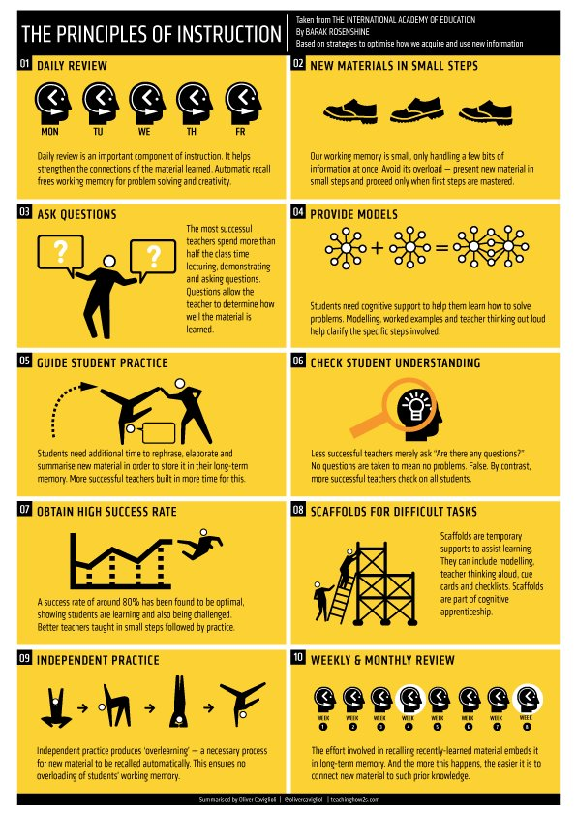**Appendix**