**HIGHFIELD FARM PRIMARY SCHOOL**

**Design and Technology Policy**

**Date of Policy approval _____________**

**Date of Policy review _______________**

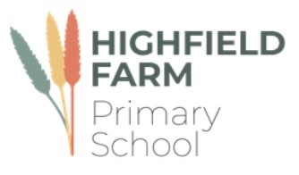

‘Design and Technology in primary schools develops children’s skills and knowledge in design, structures, mechanisms, electrical control and a range of materials, including food. It encourages children's creativity and encourages them to think about important issues.’

DATA, 2021

The teaching of Design and Technology is of great importance to our children and the wider West Melton Community. A strong start in Design and Technology learning will set the foundations for our children to become fascinated with future STEM careers and open their opportunities in sectors concerned with Science, technology, engineering and maths. At Highfield Farm Primary School we encourage children to engage with the wonderful world of design and technology and that creating something, for someone and for a purpose is an endeavor that should be fostered.

**Intent**

Design and Technology is a way of learning, which spans and links the whole curriculum. We want all children at Highfield Farm Primary School to think innovatively, to question and explore the practical world around them and to develop a positive and passionate attitude to their learning, through creative design. Teaching staff lead design technology lessons with a no ceiling approach to differentiation, taking into consideration the needs of children with SEND and the most able, enabling all children to access our challenging curriculum and to feel confident in their design decisions. Children understand how to apply their technical knowledge and justify their design decisions using key subject specific vocabulary, initial designs, mock-ups, prototypes and functional products from the conceptual through to the constructional, avoiding design fixation. We want to instill the ethos at the heart of all good design - to design, test, make and evaluate...

We recognise the important role that design and technology plays in preparing our children with the skills they can use in their life time and the potential career opportunities that it may encourage them into. Through the high quality DT education that all pupils at Highfield Farm will receive, the children will gain a love for the subject in its own right, appreciate the value it has in societal development and how learning from it can drive forward aspirations for themselves and of others.

Our aim is that our children go on to apply taught design and technology skills across other subject disciplines subjects, aswell as draw upon knowledge from other disciplines when required. Our carefully crafted curriculum is designed to provide our children with the subject specific language they need to describe, question and discuss ideas relating to the design. Indeed, it is one of the ‘foundations’ aspects of the curriculum at Highfield Farm that will add real value to the children’s primary education.

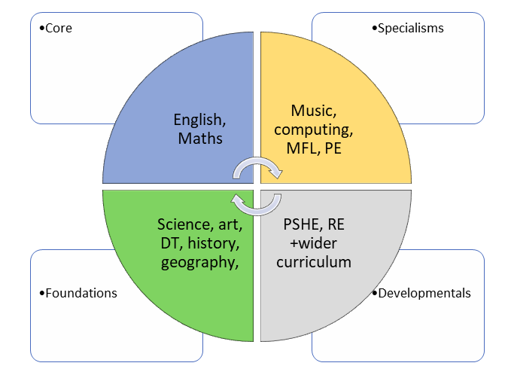

The curriculum is split into three different areas: ‘**cook**’, ‘**sew**’ and ‘**build**’. It is designed so that each year group will complete a unit of work in these three different areas once a year. The appendix highlights the units taught in each year groups and the areas being covered. Two different ‘aspects’ of design are interwoven into the three areas of study: the environment and sustainability, and enterprise and innovation. These ‘aspects’ acknowledge enduring and contemporary concerns of modern design. The curriculum is designed to be delivered alongside the PKC art, science and history curricula, as parts of it directly relate to areas of knowledge which the pupils acquire in these subjects. Where a unit looks at concepts which are also addressed in these subjects, the design and technology unit is generally taught after units in these other disciplines. This allows the children to approach their study of design and technology with a degree of confidence and ‘expertise’ and to consolidate their knowledge by creating connections between the different disciplines.

The children of Highfield Farm Primary School have a voice and have the right to use it and so should be encouraged to express their opinions. We teach and encourage the use of debate and presentation and in doing so provides a platform for our children to express their views and justifications for product design.

**Implementation**

Based upon the National Curriculum and the individual needs of our children and the West Melton community, we have created a Design and technology progression map supported by the Primary Knowledge Curriculum (PKC), which sets out the objectives taught in each year group for the following areas of the DT curriculum:

* Designing
* Making
* Evaluating
* Using technical knowledge
* Food technology

All of these key disciplinary skills are realised through design projects. We have planned for and ensure that a broad design and technology curriculum is offered which draws upon the various discipline areas of: design, structures, mechanisms, electrical control and a range of materials, including food. Our computing curriculum covers much of the content pertaining to electrical control.

Following an iterative design process is key to enabling children to evaluate and adjust their designs and products. We achieve this though various approaches such as: the use of handling displays for children to explore existing designs and products; well-structured lessons allowing time for exploration, discussion, practise and research; designing a product for a specific audience or 'client' in mind; cross-curricular links that allow children to make connections between subjects and with real-life situations and problems that may need a design solution.

**Organisation**

Due to the make up of the cohorts at West Melton, a creative approach to coverage has been taken. Design and technology is taught as part of a two year cycle in foundation stage, key stage one lower key stage 2 and upper key stage 2. key stage 2. a two-year cycle for year 1 and 2. Planning for the themes in the DT curriculum are taken from the units laid out in the PKC scheme which all staff will have access to.

**Planning**

Planning for design and technology comes from the long-term overview in the cycles as laid out in the PKC documents and broken down further into thematic DT units which act as the medium term planning. All teachers are responsible for using the PKC units (MTP) and use them as the starting points for planning sequences of lessons that build upon prior knowledge. It is the teacher’s responsibility to break down concepts into relevant components and sequence them effectively so as not to overload the children’s short-term memories.

Each individual lesson has content that is differentiated between, and within, year groups so that learning is age-appropriate and high expectations are maintained. Individual and/or sequences of lessons must take into account the following principles of instruction as laid out by Barak Rosenshine. This will add clarity and simplicity to the teaching and learning process within DT. (See Appendix) This is not to say that every principle is to be seen in every single lesson. The purpose of reviewing material is key in ensuring that material becomes stored in the long term memory, allowing for schemata to develop and new learning to then occur.

**Oracy within the curriculum**

At Highfield Farm primary School we use oracy as a means to ‘learn to talk’ and ‘talk to learn’. Our staff use strategies to promote talk in lessons which aims at not only developing the children’s ability to talk effectively for a variety of purpose, but also as a means to develop their understanding of the content being taught.

**The importance of vocabulary**

Teachers use questioning, and provide opportunities for discussion and investigation to support the development of specific design and technology language and vocabulary, which is explicitly taught and modelled by teachers in every lesson. Key technological terms and language (such as, mechanism, mock-up, design, evaluate, weave, function, construct) are revisited frequently, to make learning memorable, relevant and easy to retrieve. This is complimented by our vocabulary policy. Each unit of work has built within it, lists of specific disciplinary vocabulary that should be taught to the children.

**The place of reading**

Reading is central to the teaching and learning of DT and indeed is key to learning. As the children move through the phonics teaching and become competent in their ability to read, they will be exposed to a greater selection of high-quality books and texts, and this will include non-fiction texts in the discipline of DT and the wider STEM disciplines. In doing so, the children at Highfield Farm Primary School will be exposed to the academic language of schooling and the disciplinary vocabulary in the subject. As a consequence of such a focus on academic reading, our pupils will be far better prepared for transition into secondary school and the format of teaching and learning they will experience. High quality nonfiction STEM related texts are updated annually with the support of the English subject leaders. Such books will be highly visible in classrooms and around displays in the corridors.

**EYFS**

We teach design and technology in our foundation stage classes as an integral part of the topic work covered during the year. The foundation planning is on a 2 year cycle. We relate the DT aspects of the children’s work to the objectives set out in the Early Learning Goals (ELGs) which underpin the curriculum planning for children aged three to five. Design and technology makes a significant contribution to the development of each child’s knowledge of being expressive and creating with materials. A crucial aspect of this is ensuring that children exit foundation with the key language, vocabulary and knowledge to build upon in the key stage one DT curriculum. For example, Safely using and a variety of materials, tools and techniques, being able to experiment with colour, design, texture, form and function and then being able to explain the processes they have used in their creations.

**Impact**

The impact of our DT curriculum is measured in a variety of ways: questioning during lesson time, evaluating children’s designs, processes and end products, listening to child-led discussion, interviewing pupils across the school about their learning, book trawls and using images/videos of children’s practical learning.

By end of the DT curriculum at Highfield Farm Primary School, our children will:

• Have a growing knowledge of the importance of design and technology in society and the wider world

• Have a wider vocabulary of design and technology specific terms.

• Aspire to discover more about STEM , through wider reading or other medium.

• Know that they can use their voice to express themselves and their opinions.

• Develop their DT skills, such as, designing, making and evaluating functional products

**Appendix**



