|  |
| --- |
| **HIGHFIELD FARM PRIMARY SCHOOL**  **Music Policy**  **Date of Policy approval _____________**  **Date of Policy review _______________** |

*” When words fail, music speaks”*

*Hans Christian Anderson*

Our society has an incredibly rich musical culture that should be celebrated. Music is a universal language that embodies one of the highest forms of creativity. A high-quality music education should engage and inspire pupils to develop a love of music and their talent as musicians, and so increase their self-confidence, creativity and sense of achievement. As pupils progress, they should develop a critical engagement with music, allowing them to compose, and to listen with discrimination to the best in the musical canon. At Highfield Farm we endeavour to add to our pupil’s musical culture in supporting the overall acquisition of cultural capital. Crucially, at Highfield Farm we believe that music can be a powerful alternative to the written word when expressing yourself.

**Intent**

Our vision for music is that we provide every child with high quality music experiences which engages and inspires them. We provide opportunities for all children to create, play, perform and enjoy music and to appreciate a variety of music styles. We aim for every child to leave Highfield Farm Primary School with a range of musical skills, knowledge (tactit, procedural and declarative) that prepares them for transition to KS3 and KS4 and leave them with an enduring love of music which they can carry with them for the rest of their lives. Our pupils will gain a strong appreciation for the beauty and power that music has in its own right as a subject.

Our carefully crafted curriculum is designed to provide our children with the subject specific language they need to describe, question and discuss concepts relating to the music. Indeed, it is one of the ‘specialisms’ aspects of the curriculum at Highfield Farm that will add real value to the children’s primary education and compliment the other three elements in a holistic view of child development.

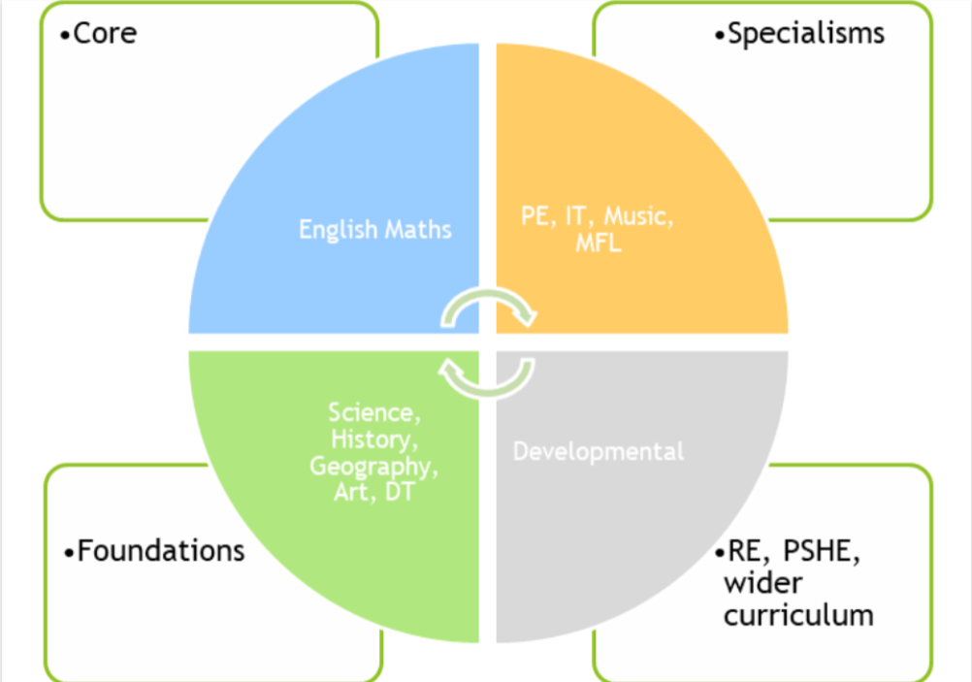

**Implementation**

Based upon the National Curriculum and the individual needs of our children and the Highfield Farm community, we use the Charanga music scheme, which sets out the objectives and concepts taught in each year group for the following areas of the music curriculum

The Charanga Musical School Scheme provides teachers with week-by-week lesson support for each year group in the school. The Scheme supports all the requirements of the national curriculum. In line with the curriculum for music and guidance from Ofsted, this Scheme moves away from the previous levels and learning objective/outcome concepts to an integrated, practical, exploratory and child-led approach to musical learning. Throughout the implementation of our music curriculum, Rosenshine’s principles of instruction will inform music lessons.

**Sequencing**

Charanga Musical School Units of Work enable children to understand musical concepts through a repetition-based approach to learning. Learning about the same musical concept through different musical activities enables a more secure, deeper learning and mastery of musical skills.

Musical teaching and learning is not neat or linear. The strands of musical learning, presented within the lesson plans and the on-screen resources, are part of the learning spiral. Over time, children can both develop new musical skills and concepts, and re-visit established musical skills and concepts. Repeating a musical skill doesn’t necessarily mean their progress is slowing down or their development is moving backwards! It's just shifting within the spiral. Mastery means both a deeper understanding of musical skills and concepts and learning something new.

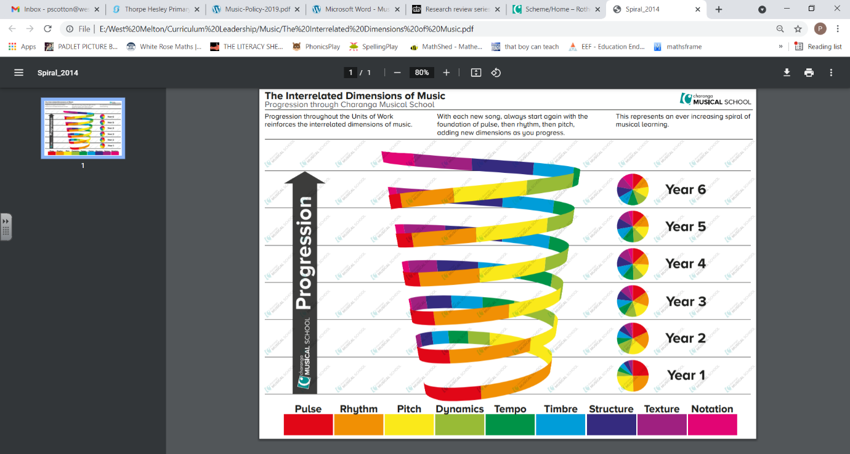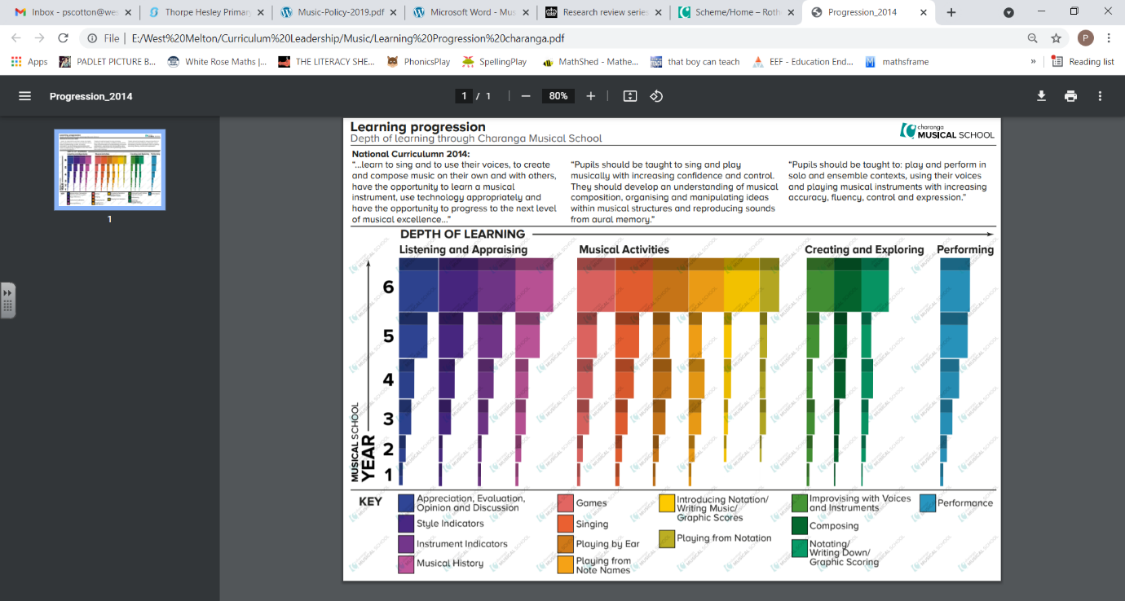

**Music across the school (listening and singing)**

Almost daily, the children will listen to music at various points in the classroom. The timing of this is at the discretion of the teacher. This music will be played mainly from the Charanga listening library and provide opportunities for children to be exposed to music from various eras, various genres, various styles and various composers. In doing this the children throughout their whole schooling experience at Highfield Farm will have been exposed to a vast musical canon.

During singing assemblies, songs to be taught are selected from the sing aspect of the Charanga scheme.

**Oracy within the curriculum**

At Highfield Farm Primary School, we use oracy as a means to ‘learn to talk’ and ‘talk to learn’. Our staff use strategies to promote talk in lessons which aims at not only developing the children’s ability to talk effectively for a variety of purpose, but also as a means to develop their understanding of the content being taught.

**The importance of vocabulary**

Teachers use questioning, and provide opportunities for discussion and investigation to support the development of specific music related language and vocabulary, which is explicitly taught and modelled by teachers in every lesson. Key musical terms terms and language (such as, pulse, rhythm, pitch) are revisited frequently, to make learning memorable, relevant and easy to retrieve. This is complimented by our vocabulary policy.

**EYFS**

We teach music in our foundation stage classes as an integral part of the topic work covered during the year. The foundation stage accesses the Charanga materials in their respective sections. We relate the musical aspects of the children’s work to the objectives set out in the Early Learning Goals (ELGs) which underpin the curriculum planning for children aged three to five. The Charanga scheme includes a variety of adult-led and child-initiated activities delivered through planning and play, all the musical learning is focussed around nursery rhymes and action songs. It fully supports in the acquisition of the Early learning goal of being imaginative and expressive.

**Impact**

The impact of our music curriculum is measured in a variety of ways: questioning during lesson time, appraising children’s performances in singing and response to teaching, listening to child-led discussion, interviewing pupils across the school about their learning and using images/videos of children’s practical learning.

By end of the music curriculum at Highfield Farm, our children will:

• Have a growing knowledge of music. (History, styles, genres, eras)

• Have a wider vocabulary of musical terms and concepts

• Know that they can use their voice to express themselves and their opinions.

• Develop their musical skills, such as, appraising musical pieces, singing with confidence and composing with greater ease.

