

Class 1/2

Spring 1

This term sees us working on a variety of high-quality texts that are often linked together by common themes. The wonderful texts we are going to explore this term are:

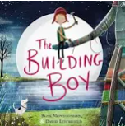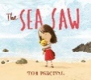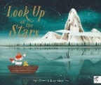

The table below describes what is happening in each of the subject areas.

|  |  |
| --- | --- |
| **English** | Much of our English will be based on stories with some predictable language. Some of the themes that the books address include hope, children will learn about **list making**, writing **descriptions**, writing **letters** and writing own instructions. The children will also be taught the some grammatical and spelling features of English including the use of **past tense**, **commas in a list** and the **use of apostrophes.** |
| **Maths** | Much of this half term will revolve around **developing a stronger understanding of addition and subtraction as well as starting our learning on multiplication and division** This will be taught with concrete apparatus and pictures to support their thinking. |
| **Geography** | Our unit this half term is called ‘**United Kingdom**. This unit will introduce children to the idea of how the UK is formed which includes England, Northern Ireland, Scotland and Wales. They will use atlases, maps and digital maps to explore the UK and some of its features. |
| **Music** | We use the Charanga scheme to support our learning in music. This half term the theme will be ‘**In the groove.**. The children will start to learn about the difference between pulse, rhythm and pitch and various styles of music. |
| **PE** | Please make sure that your children come to school dressed in **full PE kit to school every Tuesday and Friday** including track suit bottoms and tops and suitable footwear. The children will be participating in a variety of fundamental movement skills and gymnastics. Please make sure that **all jewellery** is removed before attending school or **tape up the earrings**. |
| **PSHE** | The main focus for this subject this half term is on **Dreams and Goals.** The children will learn about what it means to have a dream and be motivated to strive towards it. They will recognise within themselves what it is they are good at and celebrate it. |
| **RE** | This half term the children will find out about ‘**what festivals Jewish people like to celebrate?** This unit enables pupils to begin to understand aspects of the Jewish way of life through play, story, artefacts and listening. The focus is on the importance to the Jewish people, of God, the family and stories from the Torah, showing how their beliefs are expressed in practice. |
| **Computing** | Our focus for this term is on **programming.** The children will develop their understanding of a range of tools for creating animations using scratch jr. They then use these tools to create their simple animations by creating simple code and using simple algorithms. The children will explore the way a project looks by investigating sprites and backgrounds. They will use programming blocks to use, modify, and create programs. |
| **Art** | Our focus this half term will be on the topic of **architecture.** This unit introduces children to the art of designing buildings. The children will build on their understanding of line within art and apply it to the study of significant architecture from our capital city, London. These building include St Paul’s Cathedral, Westminster Abbey and The houses of Parliament. |
| **Science** | This unit is an introduction to every day **materials and their properties**. Pupils will begin to understand that scientists and engineers study the properties of materials before making decisions. |

**Learning you could do at home**

Reading

Every week your child will have access to a phonically decodable book that supports what they have been learning in their phonics lessons. They will have a paper version of the book they are reading as part of their reading group to work on at home. They will also bring home a book bag book which is another book they can read and should be decodable by your child. Please hear them read these books. The more often they read, the better they will get. **We expect all our children to read a minimum of four times a week**. Your child may also come home with links to **phonics videos** to further support their word reading ability and small speed sound booklets for them to work on their sound recognition. Please let us know how your child is reading at home via Dojo.

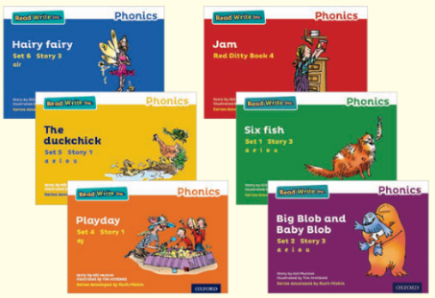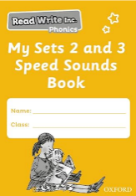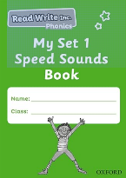

**Our school library**

The school has a library of books that the children can borrow from and enjoy at home. The books they choose are to be enjoyed by the whole family. These books may be too difficult for your child to read on their own and so we recommend that the books are read to them by an adult. If you would like to, you can come in to our library and choose a book with your child. This is always best at the end of the day.

The school website also has a **virtual library** which has some recommended reads for all our children in virtual and video format. These books will be changed every half term. <https://www.highfieldfarmprimary.co.uk/general-1>

**Maths at home** 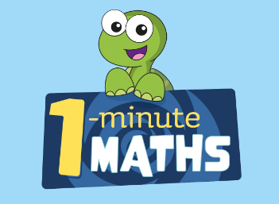

Use one minute maths to work on basic subitising, addition, subtraction as well as multiplication skills.

In this half term, the children will be exploring shape in a lot of detail. Take the opportunity to become shape artists and create your own shape paintings, pictures or drawings.

Some fun games that you might like to try are:

Nim and ones and twos which can be found here: <https://atm.org.uk/maths-teaching-resources/maths-snacks-videos>

And Dotty 6- <https://nrich.maths.org/problems/dotty-six>

Visit the maths frame website for lots of fun maths games to work on those basic skills. <https://mathsframe.co.uk/en/resources/category/22/most-popular>

**Science at home**

Use the school website to access lots of science geography and history activities. <https://www.highfieldfarmprimary.co.uk/general-1-2>

Send in pictures of your winter adventures so your child can talk about them to the adults and / or peers. Could your child find interesting things to take pictures of when out and about with you during the winter season?



We would love to celebrate home learning, please send in any work or why not send us a photo on Dojo.