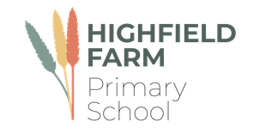

Class 3/4

Autumn Term 2

This term sees us working on a variety of high-quality texts that are often linked together by common themes. The wonderful texts we are going to explore this term are:

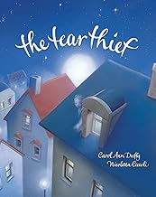 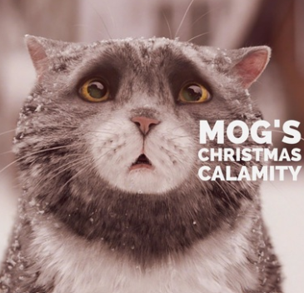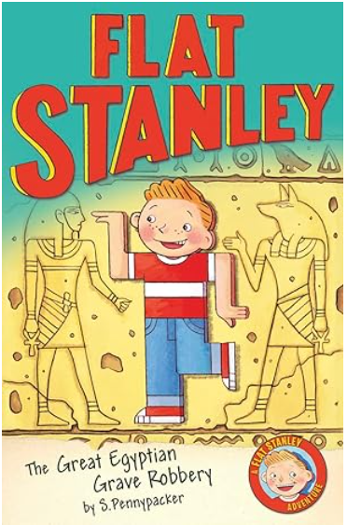 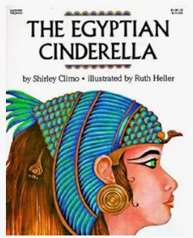

The table below describes what is happening in each of the subject areas.

|  |  |
| --- | --- |
| **English** | Much of our English will be linked to the story The Tear Thief by Carol Ann Duffy. We will learn how to use the conjunctions when, if, because, although along with fronted adverbial phrases and punctuation direct speech |
| **Maths** | Much of this half term will revolve around **securing a strong understanding of multiplication and division** as well as **measuring area**. Children will be taught with concrete apparatus and pictures to support their thinking. |
| **Geography** | This half term we will be learning about **Settlements**. The children will learn about the differences between a hamlet, village, town and city. In this unit children will be able to describe both rural and urban areas. |
| **History** | This half term our learning will around The Ancient Egyptians. We will make comparisons about Egypt and what was happening in Britain at the same time from our learning last half term about the Stone Age |
| **Music** | We use the Charanga scheme to support our learning in music. This half term children will begin to play the glockenspiel and read musical notation. |
| **PE** | Please make sure that your children come to school dressed in **full PE kit to school every Wednesday and Friday** including track suit bottoms and tops and suitable footwear. The children will be participating in a variety of fundamental movement skills and gymnastics. |
| **PSHE** | The main focus for this subject this half term is on Celebrating difference**.** The children will learn about different families and managing conflict. |
| **RE** | This half term the children will explore the question ‘**What makes Jesus inspirational to some people?** The Children will think about what makes a person inspirational, identifying characteristics of a good role model along with the impact Jesus can have on peoples lives and how they may be inspired by him. |
| **Computing** | Our focus for this term is on **desktop publishing.** The children will develop their understanding of how text and images can be used to communicate. They will use desktop publishing software and consider careful choices of font size, colour and type to edit and improve premade documents. Children will be introduced to the terms ‘templates’, ‘orientation’, and ‘placeholders’ and begin to understand how these can support them in making their own template for a magazine front cover. |
| **Art** | Our focus this half term will be on the topic of **‘Egyptian art’.** Children willlearn that art of ancient Egypt includes sculpture, paintings on papyrus and walls as well as buildings. Much of the art that we have from ancient Egypt is from tombs and the children learn that the artwork that remains shows us not only about what the ancient civilisation believed about the afterlife but also about how they lived, how they were ruled and the power of the pharaohs. |
| **DT** | Our focus for this half term will be on making **bookmarks** and developing our sewing skills. |

**Learning you could do at home**

Reading

Every week your child will have access to a reading book appropriate to their reading level. Please hear them read these books. The more often they read, the better they will get. We expect all our children to read a minimum of four times a week. Your child may also come home with links to phonics videos to further support their word reading ability and small speed sound booklets for them to practice their sound recognition. Please let us know how your child is reading at home via Dojo.

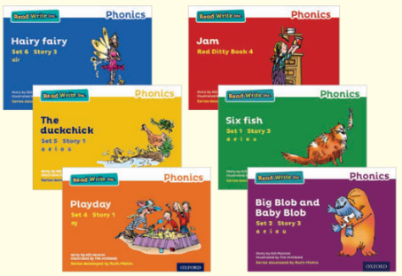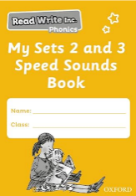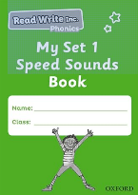

**Our school library**

The school has a library of books that the children can borrow from and enjoy at home. The books they choose are to be enjoyed by the whole family. These books may be too difficult for your child to read on their own and so we recommend that the books are read to them by an adult.

The school website also has a virtual library which has some recommended reads for all our children in virtual and video format. These books will be changed every half term.

**Geography at home**

Can you draw or make a model of a settlement?

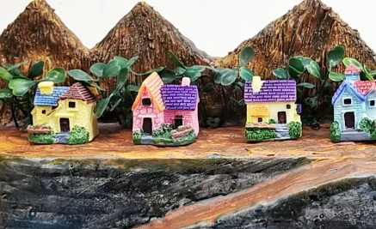

**History at home**

Research interesting facts about the Ancient Egyptians, can you make a fact file or power point presentation to share with the class?

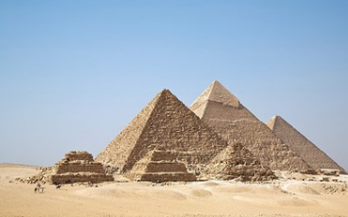

We would love to celebrate home learning, please send in any work or why not send us a photo on Dojo.