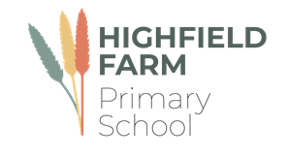

Class 1/2

Autumn Term 2

This term sees us working on a variety of high-quality texts that are often linked together by common themes. The wonderful texts we are going to explore this term are:

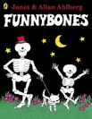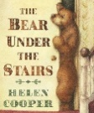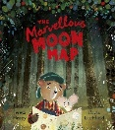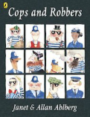

The table below describes what is happening in each of the subject areas.

|  |  |
| --- | --- |
| **English** | Much of our English will be based on stories with a familiar setting and reflecting the seasons and time of the year. The children will learn about **list making**, writing **descriptions**, writing **letters** and writing own versions of well-known **stories**. |
| **Maths** | Much of this half term will revolve around **securing a strong understanding of number and place value with larger numbers** as well as basic **addition and subtraction up to 20 and shape.** This will be taught with concrete apparatus and pictures to support their thinking. |
| **History** | Our unit this half term is called ‘**Discovering history’**. This unit will introduce children to the concept of the past, they will look at pictures, hear stories and will begin to understand that there were lives lived before theirs. |
| **Music** | We use the Charanga scheme to support our learning in music. This half term the theme will be ‘**Rhythm in the way we walk**. The children will start to learn about the difference between pulse, rhythm and pitch. |
| **PE** | Please make sure that your children come to school dressed in **full PE kit to school every Tuesday and Thursday** including track suit bottoms and tops and suitable footwear. The children will be participating in a variety of fundamental movement skills and gymnastics. Please make sure that all jewelery is removed before attending school or tape up the earings. |
| **PSHE** | The main focus for this subject this half term is on **celebrating difference.** The children will learn about what it means to besafe and special and what it means to belong to a class.The children will also have a visit from the NSPCC about stay safe and speaking out. |
| **RE** | This half term the children will find out about ‘**How do Christians celebrate Christmas?** This unit of work is intended to enable pupils to explore the importance of a key festival in the Christian calendar. The children will begin to talk about beliefs, and they will have the opportunity to think about their own experiences of celebrations with their families, including at Christmas time and many other celebrations. They will talk about the traditions that they follow each year and will realise that these celebrations are an important feature of family lives, whether they are Christians or members of a different faith, or non-religious families. |
| **Computing** | Our focus for this term is on **creating media.** The children will develop their understanding of a range of tools used for digital painting. They then use these tools to create their own digital paintings, while gaining inspiration from a range of artists’ work. |
| **Art** | Our focus this half term will be on the topic of **line.** The children will learn about the element of line. It presents the idea that lines are like basic tools for artists like : Rembrandt, Miro, Klee and Pwerle which show how lines can be used to show different things, ranging from simple shapes and objects to representing dreams and patterns |
| **DT** | Our focus for this half term will be on making **items for the Christmas Fair** and developing our early **sewing** skills. |

**Learning you could do at home**

Reading

Every week your child will have access to a phonically decodable book that supports what they have been learning in their phonics lessons. They will have a paper version of the book they are reading as part of their reading group to work on at home. They will also bring home a book bag book which is another book they can read and should be decodable by your child. Please hear them read these books. The more often they read, the better they will get. We expect all our children to read a minimum of four times a week. Your child may also come home with links to phonics videos to further support their word reading ability and small speed sound booklets for them to practise their sound recognition. Please let us know how your child is reading at home via Dojo.

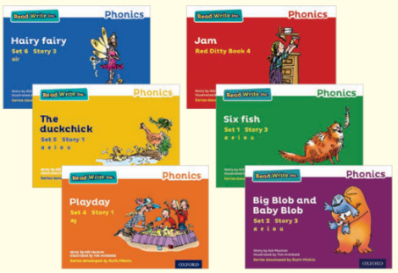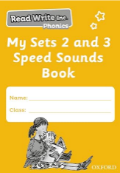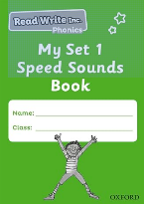

**Our school library**

The school has a library of books that the children can borrow from and enjoy at home. The books they choose are to be enjoyed by the whole family. These books may be too difficult for your child to read on their own and so we recommend that the books are read to them by an adult. If you would like to, you can come in to our library and choose a book with your child. This is always best at the end of the day.

The school website also has a virtual library which has some recommended reads for all our children in virtual and video format. These books will be changed every half term.

**Maths at home** 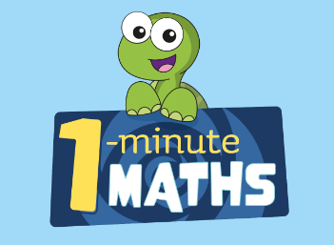

Use one minute maths to work on basic subitising, addition, subtraction and doubling and halving skills. In this half term, the children will be exploring shape in a lot of detail. Take the opportunity to become shape artists and create your own shape paintings, pictures or drawings.

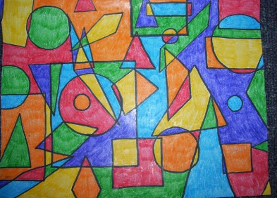 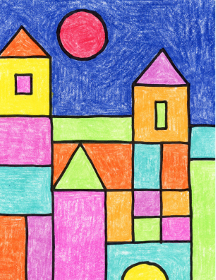

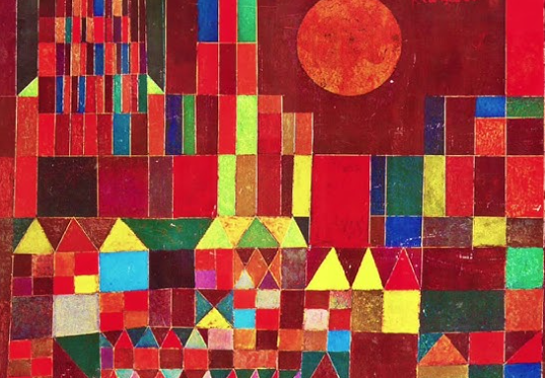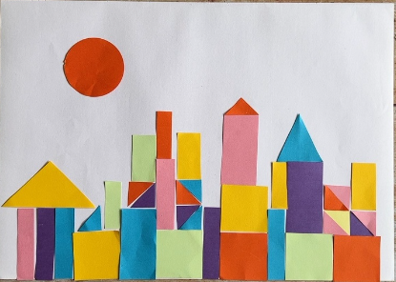

Visit the maths frame website for lots of fun maths games to work on those basic skills. <https://mathsframe.co.uk/en/resources/category/22/most-popular>

**Science at home**

The seasons are changing. Take the opportunity to go for walks with family and friends in woodlands, parks and countryside and discuss with your child how the seasons change from Summer to Autumn .

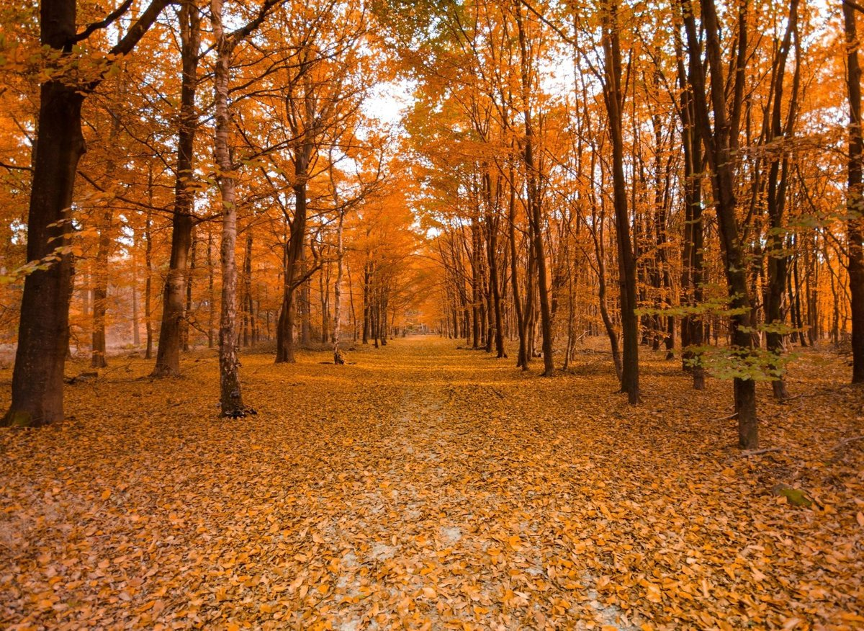

Send in pictures of your Autumn adventures so your child can talk about them to the adults and / or peers.

We would love to celebrate home learning, please send in any work or why not send us a photo on Dojo.