|  |
| --- |
| **Highfield Farm Primary School**  **History Policy**  **Date of Policy approval _____________**  **Date of Policy review _______________** |

“the more you know about the past, the better you are prepared for the future” –Theodore Roosevelt

The teaching of history gives pupils an ever increasing understanding of how the world was and how it came to be to this present day. At Highfield Farm Primary School we want to encourage a rich dialogue with the past and for our pupils to gain an appreciation for the story of human development. Events that unfold through time should be studied by the pupils with a historical gaze in order to better inform their future. Using the Primary Knowledge Curriculum as a means of delivering our history ensures that we meet our ambition.

**Intent**

At Highfield Farm Primary School, through our history curriculum, we aim to expand historical vocabulary, increase our children’s knowledge about the past on a local, regional, national and international basis. We recognise the important role that history plays in preparing our children with the skills they can use in their life time. Through the high quality history education that all pupils at Highfield Farm Primary School will receive the children will gain a love for the subject in its own right, appreciate the value it has in understanding cultural and societal change and how learning from it can drive forward aspirations for themselves and of others. A principle we hold dear is recognising and acknowledging our past whilst striving forwards in making positive choices now and in the future.

Children, through history, are encouraged to ask perceptive questions, sift arguments, weigh evidence, think critically and develop perspective and judgement. At Highfield Farm Primary School pupils will be encouraged to think deeply and engage in enquiry. History at Highfield Farm Primary School enables our learners to be proud of their local heritage, to develop a sense of their own identity and the challenges and changes within their local area. Our curriculum seeks to provide learners with a growing understanding of the complexity of people’s lives, the process of change, equality and diversity within societies and develop an understanding of the relationships between different groups of people.

Our aim is that our children go on to apply these skills across all subjects, and can draw upon their knowledge in other disciplines. The Primary Knowledge Curriculum aspires to create curious and knowledgeable young people, who hold a deep understanding and appreciation of the discipline of history, and are able to sift and weigh evidence to begin to formulate their own viewpoints and perspectives of the world. Indeed, it is one of the ‘foundations’ aspects of the curriculum at Highfield Farm Primary School that will add real value to the children’s primary education and later academic study.

**Highfield Farm 4 Element Curriculum Model**

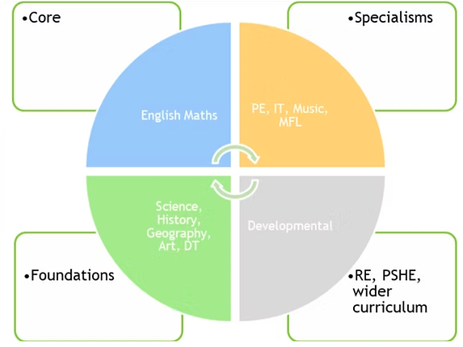

The children of Highfield Farm Primary School have a voice and have the right to use it and so should be encouraged to express their opinions. We teach and encourage the use of debate within a range of emotive and controversial historical topics such as WW1 and WW2, refugees and immigration. The Primary Knowledge Curriculum will produce well rounded and informed pupils whose **cultural capital** is expanded and whose skills and knowledge can be applied across the curriculum.

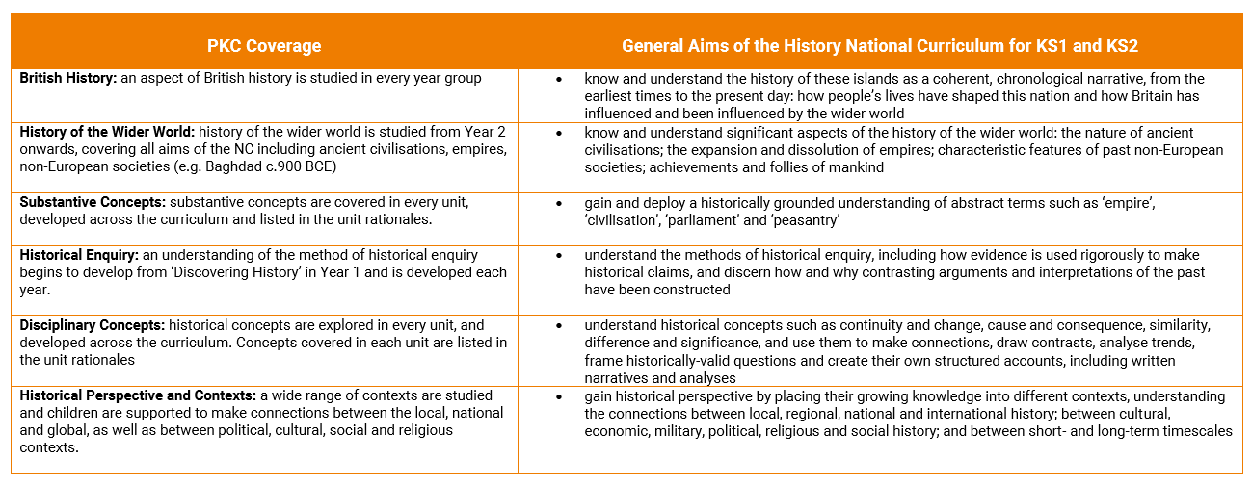

**Implementation**

Based upon the National Curriculum and the individual needs of our children and the Highfield Farm Primary School, we have adopted the Primary Knowledge Curriculum (PKC) for the delivery of our entire history curriculum. The PKC history curriculum has been designed to be both knowledge-rich and coherently sequenced. Knowledge, in the realm of history, means not only **substantive knowledge** of historical events, dates and people in the past, but also knowledge of **substantive concepts** in history (such as ‘empire’, ‘monarchy’ and ‘civil war’), and disciplinary historical concepts (such as evidence, causation, significance and interpretation). The PKC history curriculum allows children to develop a **chronologically secure** knowledge and understanding of local, British and world history. The substantive knowledge taught in the curriculum has been carefully chosen and sequenced using a largely chronological approach. Each unit of work should not be viewed as a stand-alone topic, but as a chapter in the story of the history of Britain and the wider world. In this sense, the chronological approach provides a solid framework, anchoring each unit within a **wider narrative. Disciplinary concepts**, such as continuity and change, cause and consequence and similarity, difference and significance, are explored in every unit, and children are supported to think outside of their current unit of work and apply these concepts across the curriculum.

**Organisation**

Due to the make up of the cohorts at Highfield Farm Primary School, a creative two-year cycle approach to coverage has been taken. Planning for the themes and topics in the history curriculum are taken from the medium term planning documents within the PKC online resources. Cycle A takes into account the lower age group units within a key stage. Cycle B takes into account the higher age group within the key stage.

The following table indicates the historical units that are studied during the children’s Highfield Farm Primary School’s career.

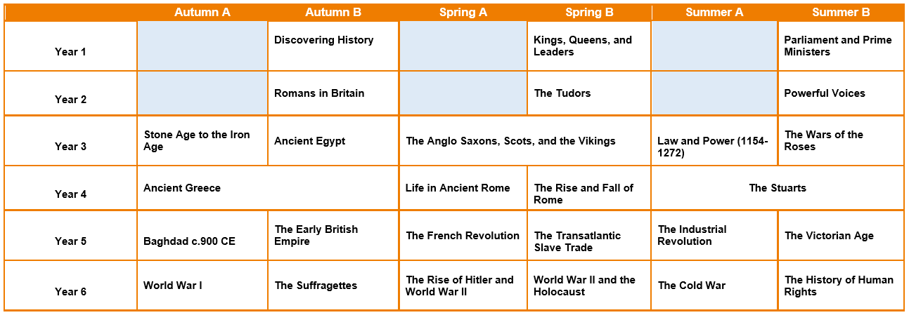

Owing to the importance of history in its own right and in order to minimise the potential for a diluted history curriculum, we have favoured an enquiry focused approach where history is stand alone. However, where links to the wider curriculum can be made, they are acknowledged. The history curriculum will support in providing the background knowledge to an English topic and the driving texts behind them and the vital cultural capital to engage at a deeper level with the text seen within the main English lessons. This is especially the case to enrichen the GPA English work. To this end, all history learning is presented in a separate history text book. This will show very clearly the progression of substantive and disciplinary knowledge as the children move through their primary education at Highfiled Farm Primary School.

**Sequencing**

The units identified and planned for in our history curriculum have been selected and placed as such with meticulous consideration. In order for substantive knowledge and concepts to become stronger and the schema for abstract terms to develop in such a way that the long term memory is utilised, the units have been placed on our curriculum map to add a developmental undercurrent to teaching. Knowledge of substantive concepts and disciplinary concepts have been interleaved across the curriculum, allowing children to encounter and apply these in different contexts. From year to year, unit to unit, lesson to lesson, the curriculum supports children in making connections and building upon prior substantive and disciplinary knowledge. We understand that such abstract terminology and substantive knowledge is taught in repeated encounters in specific and meaningful contexts.

**Chronological understanding**

Our position on pupil’s chronological understanding is clear. It matters a great deal! In part supported by cognitive science and long term memory, the teaching of chronological understanding at Highfield Farm Primary School has been designed in such a way that all pupils gain secure chronological understanding, allow for studying history in overview and in depth and stops the fragmented and episodic teaching. The PKC history curriculum allows children to develop a chronologically secure knowledge and understanding of local, British and world history. The substantive knowledge taught in the curriculum has been carefully chosen and sequenced using a largely chronological approach. Each unit of work should not be viewed as a stand-alone topic, but as a chapter in the story of the history of Britain and the wider world. In this sense, the chronological approach provides a solid framework, anchoring each unit within a wider narrative. Understanding in history requires an understanding of causation. Children will be able to understand the causes of significant national and global events, (such as World War I), when they have some background knowledge of what happened before (such as the origins and growth of European empires, including the British Empire).

In doing so, the pupils repeatedly return to the idea of chronology with a mental timeline becoming stronger and stronger from which to base future historical learning from. Learning about chronology in such a manner goes some way in providing the vital background knowledge that is required in good historical teaching.

In order to develop the whole school understanding of chronology, every class will display a timeline. The corridor in school will also have a dedicated timeline showing major milestones in history from a local, regional, national and international perspective and significance.

**Disciplinary knowledge**

Great care of the planning sequences at a macro and micro level of the history curriculum takes into consideration the nuances of historical disciplinary knowledge. The development of such skill sets and knowledge is not left to ks2, but is taught alongside the substantive knowledge of the topics in EYFS and ks1 at an age and stage appropriateness. This ensures that a repeated encounter occurs and the schema for such disciplinary knowledge develops cumulatively. Enquiry questions are used to frame the units across the school curriculum of which the substantive and disciplinary knowledge will come from and have focus. The disciplinary concepts taught at Highfield Farm Primary School are:

* cause
* consequence
* change and continuity
* similarity and difference
* historical significance
* sources and evidence
* historical interpretations

**Diversity**

The Highfield Farm history curriculum has been designed in such a way that celebrates and promotes local and cultural identity whilst at the same time making efforts to avoid tokenism. The breadth of historical periods of time, societies and places whilst ensuring diversity and representativeness, are woven into the whole curriculum and not a bolt on. For us, allowing all our pupils to see themselves in the history is vital, giving relevance and real value to its current and future study.

**Planning**

Planning for history comes from the long term overview in the cycles as laid out above, and broken down further into thematic historical units which act as the medium and short term planning. All teachers are responsible for using such planning materials to deliver from and tailor for the needs of the children within their classroom. It is the teacher’s responsibility to break down concepts into relevant *components* and *sequence them effectively so as not to overload the children’s short term memories*.

Each individual lesson has content that is differentiated between, and within, year groups so that learning is age-appropriate and high expectations are maintained. Individual and/or sequences of lessons must take into account the principles of instruction as laid out by Barak Rosenshine. This will add clarity and simplicity to the teaching and learning process within history. (See Appendix) This is not to say that every principle is to be seen in every single lesson. The purpose of reviewing material is key in ensuring that material becomes stored in the long term memory, allowing for schemata to develop and new learning to then occur.

**The importance of vocabulary**

Teachers use questioning, and provide opportunities for discussion and investigation to support the development of specific historical language and vocabulary, which is explicitly taught and modelled by teachers in every lesson. Key historical abstract terms and language (such as, monarchy, parliament, church, sacrifice) are revisited frequently, and specifically indicated within the short term planning sequences. This is complimented by our vocabulary policy.

The teaching of vocabulary has been specifically designed to also take account of introducing children to specific terminology that will support future learning.

**Oracy within the curriculum**

At Highfield Farm primary School we use oracy as a means to ‘learn to talk’ and ‘talk to learn’. Our staff use strategies to promote talk in lessons which aims at not only developing the children’s ability to talk effectively for a variety of purpose, but also as a means to develop their understanding of the content being taught.

**The place of reading**

Reading is central to the teaching and learning of history and indeed is key to learning. As the children move through the phonics teaching and become competent in their ability to read, they will be exposed to a greater selection of high quality books and texts, and this will include non-fiction texts in the discipline of history. In doing so, the children at Highfield Farm Primary School will be exposed to the academic language of schooling and the disciplinary vocabulary in the subject. As a consequence of such a focus on academic reading our pupils will be far better prepared for transition into secondary school and the format of teaching and learning they will experience. Furthermore, the place of narrative and storytelling is a powerful vehicle for the teaching of new content. High quality non-fiction history texts are updated annually with the support of the English subject leaders. Such books will be highly visible in classrooms and around displays in the corridors.

**EYFS**

We teach history in our foundation stage classes as an integral part of the topic work covered during the year. The foundation planning is on a one-year cycle. We relate the historical aspects of the children’s work to the objectives set out in the Early Learning Goals (ELGs) which underpin the curriculum planning for children aged three to five. History makes a significant contribution to the development of each child’s knowledge and understanding of the world and provides a good foundation for transition into key stage one. A crucial aspect of this is ensuring that children exit foundation with the key language, vocabulary and knowledge to build upon in the key stage one history curriculum. For example, knowing how to describe the past relating to something meaningful to them and the vocabulary and language associated with it. For example, the difference between the toys they play now and the toys their parents and grandparents played with. The children will be able to talk about people around them and their roles in society, know some similarities and differences about the past and now and draw on what has been read in class, finally recognising the past in settings, characters and events encountered in books that they have heard read in class.

**Impact**

The impact of our History curriculum is measured in a variety of ways: questioning during lesson time, marking children’s written work, listening to child-led discussion, interviewing pupils across the school about their learning, book trawls and using images/videos of children’s practical learning. Children will have the chance to participate in low stakes quizzes as designed by the PKC and also have the opportunity to complete longer tasks to gauge the depth of their historical understanding.

By end of the History curriculum at Highfiled Farm Primary School, our children will:

• Have a growing knowledge of how the world came to be and the significant events that have happened in the past

• Have a wider vocabulary of historical terms.

• Aspire to discover more about the past, through wider reading or other medium.

• Know that they can use their voice to express themselves and their opinions.

• Develop their historical skills, such as, evaluating sources of evidence, interpreting alternative viewpoints, forming informed conclusions.

Staff also use the following **history behaviors** to gauge and guide the extent that the children are attaining at an age appropriate level:

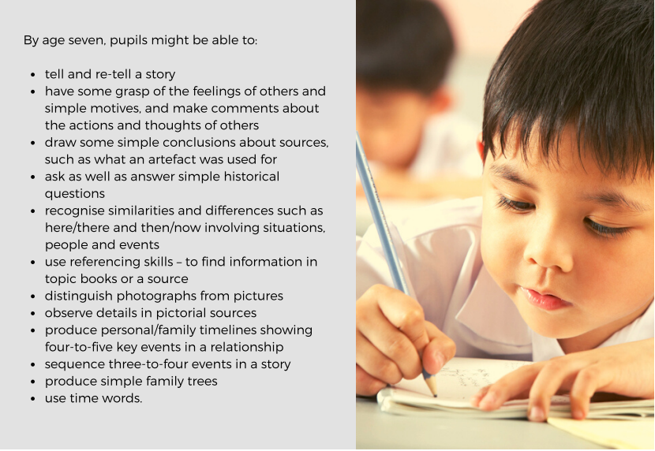

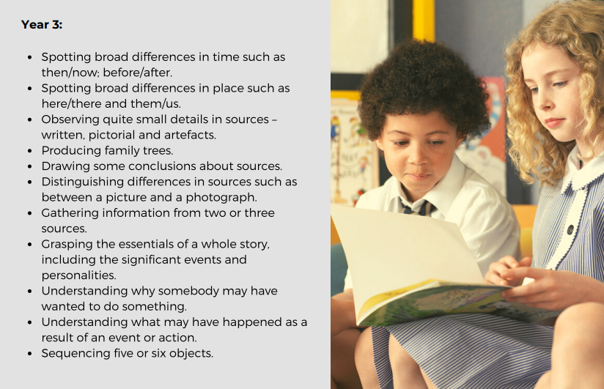

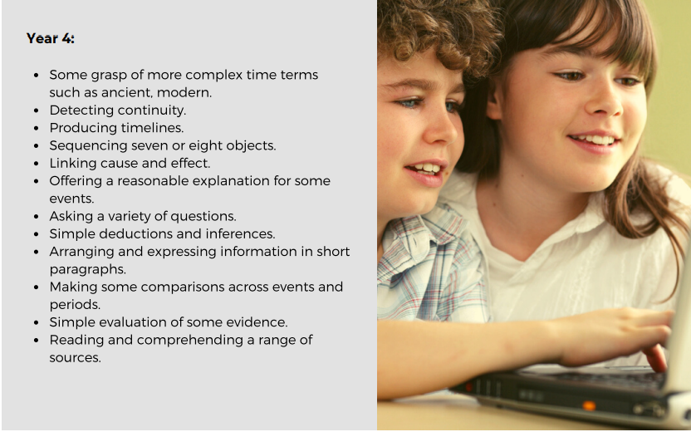

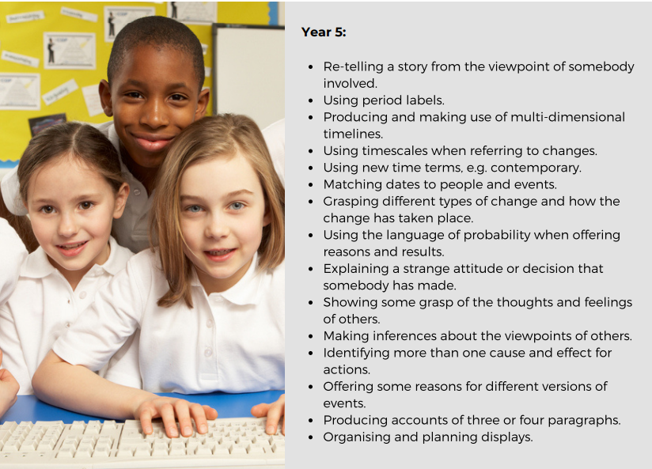

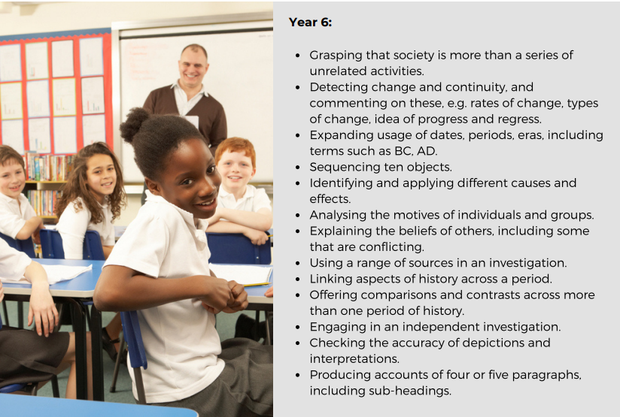

**Appendix**

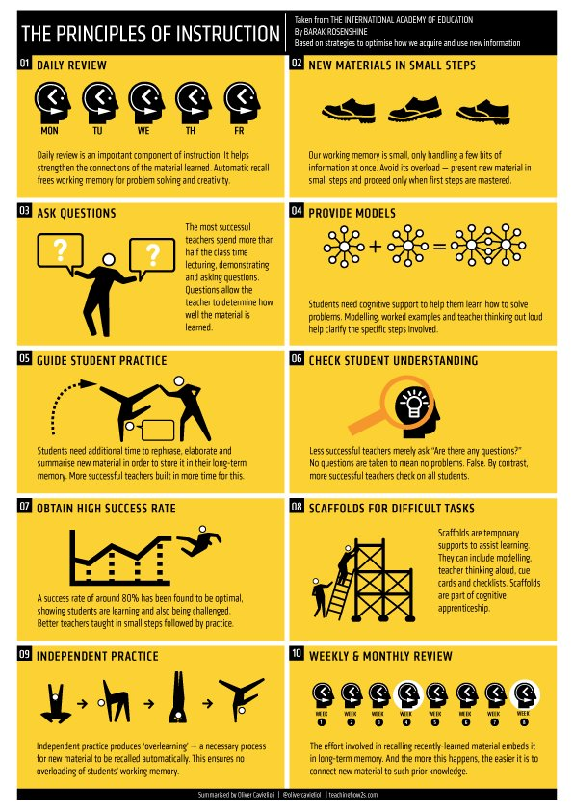

**Each unit taught and the components taught within them laid as lessons**

