Year 5/6 Spring Term



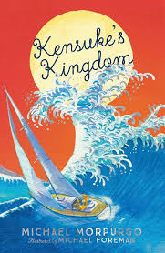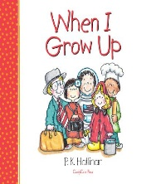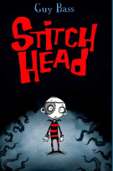This half term sees us working on a variety of high-quality texts subject areas that are often linked together by common themes. The wonderful texts we are going to explore this half term are:

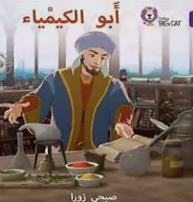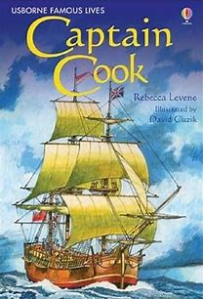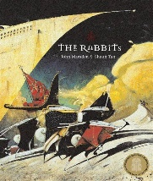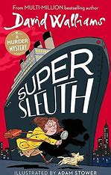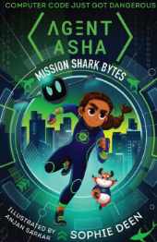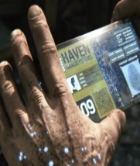 The table below describes what is happening in each of the subject areas:

|  |  |
| --- | --- |
| **English** | In English, we are using the animation Ruin to enhance a character description of an unusual doll in a shop window, whilst focussing on using a range of devices to build cohesion such as conjunctions, adverbials, pronouns and synonyms. We will also be reading the book Stitch Head, where we will be using powerful vocabulary to describe the setting in a spooky story. This will lead us to write a persuasive speech, persuading others not to go to the place where Stitch Head roams. We will be using expanded noun phrases and a variety of different punctuation in our writing; as well as, persuasive language and devices. |
| **Maths** | We are learning about how fractions; equivalent fractions with decimals leading to percentages. This will assist us with applying these mathematical strategies to calculate the area, perimeter and volume of a variety of objects and diagrams. |
| **Science** | During our science block this half term, we will be learning about materials; the properties of materials including the solubility. We will also conduct experiments as scientists by separating mixtures; including, reversible changes. |
| **History** | We are learning about the Transatlantic Slave Trade and their origins. This will enable us develop our chronological knowledge, whilst adding to our class timeline. |
| **Art** | In Art, we are developing our techniques, whilst studying art from Western Africa. |
| **PE** | We have PE lessons on Monday and Friday. PE kit will be needed and a water bottle is recommended. |
| **PSHE** | Y5/6 are learning about our dreams and goals; including, the importance of money, a job and potential careers we aspire to. This will also link to a bible story in RE about how at times, dreams can seem real, when they are not. |
| **Computing** | Within computing, we will be learning about creating media using vector drawings. This will include Google Draw and Scratch. |

**Learning you could do at home**

**Reading**

Every week your child will have access to interesting, age-related books that support what they have been learning in their reading lessons. We expect all our children to read a minimum of three times a week. Please read to your child so that you can enjoy books together. All children have access to our digital reading forum: Reading Plus, please encourage them to use this.

The more you read, the more places you will go! **Dr. Suess.**

Your child has access to a Reading Plus account and Times Tables Rockstarts account to access digital learning. They can also go on NRich to support with maths reasoning; as well as, Corbett Maths to practise arithmetic strtegies.

**If you would like any other support with learning at home please come and speak to Mrs Corker. Keep looking on Class Dojo to see photographs of our exciting learning, fun activities and events!**