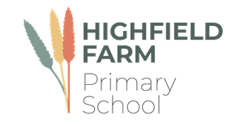

Class 3/4

Spring Term 1

This term sees us working on a variety of high-quality texts that are often linked together by common themes. The wonderful texts we are going to explore this term are:

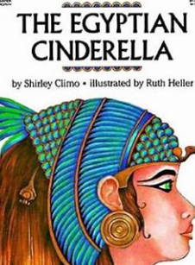 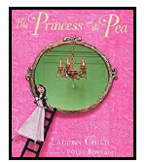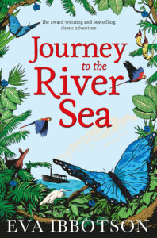 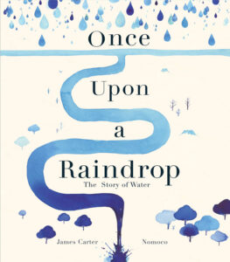 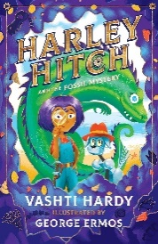

The table below describes what is happening in each of the subject areas.

|  |  |
| --- | --- |
| **English** | Much of our English will be linked to our previous history topic, The Ancient Egyptians. The children will learn how to write paragraphs around a theme and be able to proof read for spelling and punctuation errors. |
| **Maths** | Much of this half term will revolve around **securing a strong understanding of multiplication and division** as well as basic **length and perimeter** and **fractions** This will be taught with concrete apparatus and pictures to support their thinking. |
| **Geography** | This half term we will be learning about **Rivers**. The children will explore how people use rivers, for example for irrigation for farmland, for transport and as a water supply. We will be using maps, atlases, globes and digital/computer mapping to locate the rivers, the countries they journey through and to describe their features, particularly their shape and direction of travel. |
| **History** | This half term we will be learning about the Anglo-Saxons. The children will learn about the lives of people who lived in this period, how they lived, their homes, their jobs, what they ate and what they did for fun |
| **Music** | We use the Charanga scheme to support our learning in music. This half term our learning will be based on **‘Three Little Birds’** by Bob Marley. The children will learn about the difference between pulse, rhythm and pitch. |
| **PE** | Please make sure that your children come to school dressed in **full PE kit to school every Wednesday and Thursday** including track suit bottoms and tops and suitable footwear. The children will be participating in a variety of fundamental movement skills and gymnastics. |
| **PSHE** | The main focus for this subject this half term is on **Dreams and Goals.** The children will learn about setting personal goals and overcoming obstacles. |
| **RE** | This half term the children will explore the question ‘**What is it like to be a Hindu?** We will learn about how do Hindu families practice their faith along with the deeper meanings of some Hindu  festivals. |
| **Computing** | Our focus for this term is on **programming.** The children explore the concept of sequencing in programming through Scratch. We will begin with an introduction to the programming environment and be introduced to a selection of motion, sound, and event blocks which we will use to create our own programs. |
| **Art** | Our focus this half term will be on the topic of **‘Still Life and Form’.** The children will explore what a still life is and how it is a genre in art which has existed for a long time, comparing a still life painted on the walls at Herculaneum from the time of the eruption of Mount Vesuvius in Italy in 79 C.E. with pop art by Andy Warhol from the 1960s. |

**Learning you could do at home**

Reading

Every week your child will have access to a reading book appropriate to their reading level. Please hear them read these books. The more often they read, the better they will get. We expect all our children to read a minimum of four times a week. Your child may also come home with links to phonics videos to further support their word reading ability and small speed sound booklets for them to practice their sound recognition. Please let us know how your child is reading at home via Dojo.

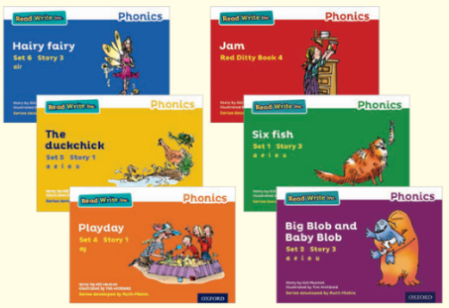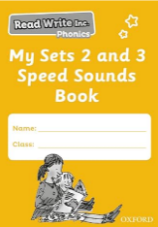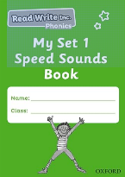

**Our school library**

The school has a library of books that the children can borrow from and enjoy at home. The books they choose are to be enjoyed by the whole family. These books may be too difficult for your child to read on their own and so we recommend that the books are read to them by an adult.

The school website also has a virtual library which has some recommended reads for all our children in virtual and video format. These books will be changed every half term.

**History at home**

Can you draw or make a model of an Anglo-Saxon long ship? Bring your creations to school and share with your class.

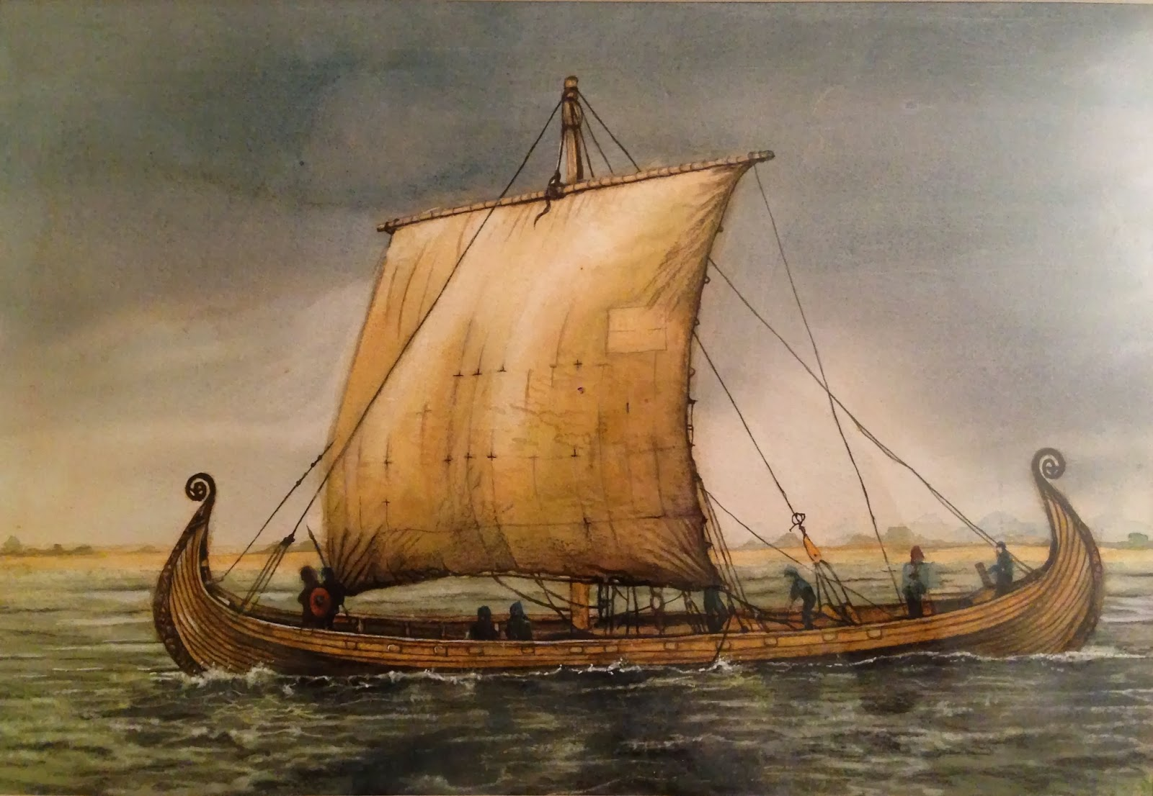

**Geography at home**

Research interesting facts about Rivers in Europe, can you make a fact file or power point presentation to share with the class?

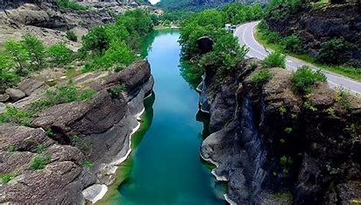

We would love to celebrate home learning, please send in any work or why not send us a photo on Dojo.