**HIGHFIELD FARM PRIMARY SCHOOL**

**Physical Education Policy**

**Date of Policy approval _____________**

**Date of Policy review _______________**



‘It aint about how hard you hit, it’s about how hard you can get hit and keep moving forwards’

At Highfield Farm Primary School, we share the view that High-quality PE is an entitlement for all pupils, regardless of their starting points or their prior experiences of sport and physical activity. We see the teaching of PE as a fundamental aspect of a child’s life and that the teaching of important knowledge can reduce barriers to participation and inform their own healthy, active lifestyle choices. Physical Education provides a gateway into the world of sport and physical activity.

**Intent**

Physical education (PE) develops the children’s knowledge, skills and understanding of a wide variety of different physical activities and sports, so that they can perform these with increasing competence and confidence. Some of these include; dance, games, gymnastics, swimming and water safety, athletics, tennis, cricket, football, rugby, basketball and more. Physical education promotes an understanding in children of their bodies in action, involving; thinking, selecting and applying a wide array of skills. PE at Highfield Farm Primary School promotes positive attitudes towards a healthy and active lifestyle through a wide range of positive experiences and supportive encouragement for everyone, allowing children to make informed choices about physical activity throughout their later lives. Staff are positive role models promoting positive attitudes towards being active for life, by sharing their own experiences of activity they do outside of the classroom and sharing their own achievements and aspirations. We embed the link between high levels of activity, not only benefiting the child’s physical health but also being a key factor of the child’s mental health also.

As a school, we have a hybrid offer of physical education. We follow the **Real PE scheme** for delivering our **Fundamental Skill** (FMS) offer**.** In doing so, we can guarantee rigor and coverage against the key fundamental movement skills required as a precursor to more sport specific activities. In many cases, our PE offer goes beyond the requirements laid out in the curriculum, by complimenting it with sport specific instruction allowing for healthy inter and intra competition. The scheme delivers, with confidence, the **first pillar of PE** **(motor competence**) as well as the **second pillar (rules, strategies and tactics ) and the 3rd pillar (healthy participation)** in a non-threatening way. Whilst the Real PE scheme does not have sport specific related games (traditional) it does teach the prerequisite skills required in the three pillars. To compliment the Real PE scheme, we have laid out sequences of learning that are more aligned to typically traditional or nontraditional sports and activities.

The real PE scheme lays out very clearly the end points for each year group and key stage and what motor competencies should have been mastered before moving on. The children at High field Farm Primary will leave with strong **declarative knowledge, procedural knowledge and appropriate vocabulary understanding conceptual development** to enable healthy lifestyle choices to be made. Children will be able to move their body with confidence due to the very specific FMS development as laid out in the real PE scheme. Thus, leaving each year ever more confident and comfortable with their own abilities.

Our PE curriculum aspires to instill the knowledge and skills for children to move on into adult life, make healthy choices about lifestyle and physical activity and enter sporting competition. We understand that staff may not have a PE background and so we have considered this in its design. Indeed, it is one of the ‘specialisms’ aspects of the curriculum at Highfield Farm Primary School that will add real value to the children’s primary education.

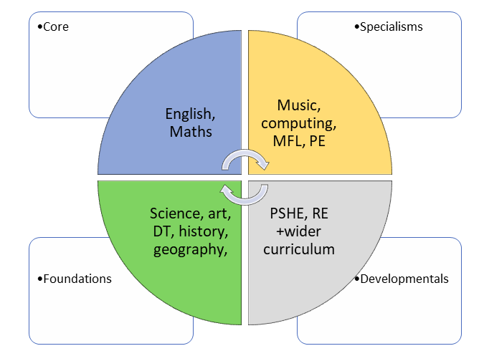

The children of Highfield Farm Primary School have a voice and have the right to use it and so should be encouraged to express their opinions and thoughts. We teach and encourage the use of discussion and debate on a regular basis as a means of children developing and expanding their thinking about physical education, sport and play. Our work on oracy is a golden thread that supports this as it does in other curricular areas.

**Implementation**

The Real PE scheme builds knowledge incrementally. Pupils have multiple opportunities to secure and build upon their knowledge by revisiting subject content at carefully sequenced points throughout the curriculum. By building upon their knowledge in a cumulative manner, the curriculum ensures pupils secure greater breadth and depth in their understanding of of the knowledge, skills and the discipline of fundamental movement skills. This progression helps children to master movement skills whilst simultaneously building up an extended subject-specific vocabulary that enables them to communicate their knowledge.

The skills that the children will learn at Highfield farm include:

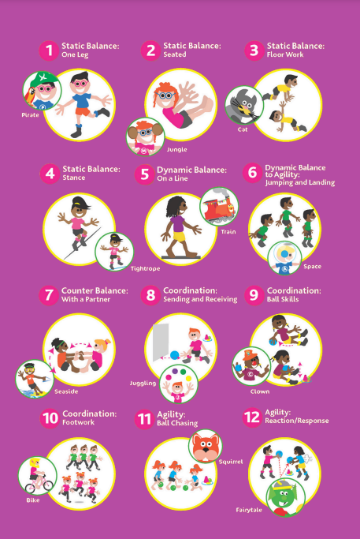

Pupils will be encouraged to use the knowledge they learn in lessons and apply it to a variety of games that have a competitive element to them. We regard competition in many forms, some of which are highlighted below.

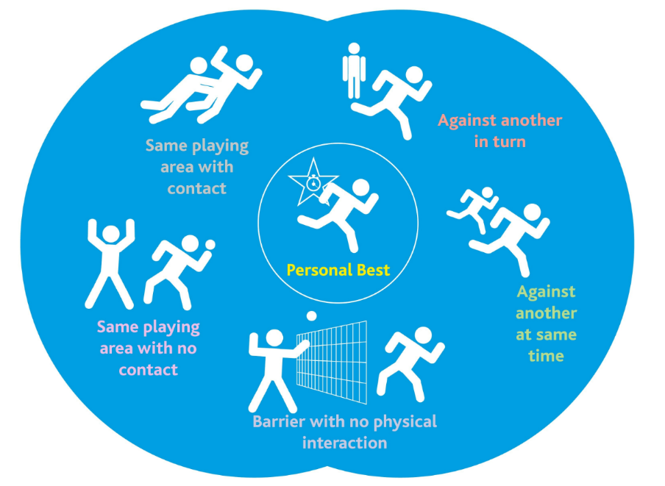

The Real PE platform allows for lessons to run in a similar pattern and with video supporting material to guide the children and the teacher. The teachers are expected to join in with the children and make adaptations to their delivery in response to the children’s needs. The Real PE scheme has resources that supports the teacher in delivering the sessions drawing upon a variety of styles. This could be focused on skill development or on developing concepts of rules and tactics in conditioned, non-traditional games. The instruction, practise and feedback that pupils receive within lesson time enables all pupils to develop their competency, reinforcing the important message that everyone can improve. This is particularly important for pupils with SEND. Our school value of keep trying is core to our lessons. By employing direct, explicit instruction using powerful models, the teachers are able to support the novice learners. Overload is considered in lessons with small steps of direct instruction and practice taken. Metacognitive strategies are fostered within the lessons where children are encouraged to challenge themselves or take steps to simplify a skill so that they gain success. This can be seen through the levelling aspect of the scheme. All children are physically active in lessons, with feedback given in small chunks but meaningful enough to be acted upon.

**Curriculum Organisation**

Due to the makeup of the cohorts at Highfield Farm Primary School, a creative two-year cycle approach to coverage has been taken. Planning for the themes and topics in the PE curriculum are taken from the medium-term planning documents within the Real PE online resources. Cycle A takes into account the lower age group units within a key stage. Cycle B takes into account the higher age group within the key stage. Within lessons however, the ability to increase challenge or simplify skills being taught is easily made through the online resources, planning and video examples.

**Planning**

Medium Term and short-term planning has been designed by curriculum experts at REAL PE. Each lesson or component includes a **rationale**, **ideas for delivery**, **Subject knowledge needed**, **specific teaching points** and specific **children’s outcomes** that pay attention to the specific FMS development as well as attend to pillars 2 and 3. All teachers are responsible for using such planning materials to deliver from and tailor for the needs of the children within their classroom. It is the teacher’s responsibility to break down concepts into relevant **components** and **sequence** them effectively so as not to overload the children’s short-term memories. Each individual lesson has content that is differentiated between, and within year groups so that learning is age-appropriate and high expectations are maintained. Challenge can be built into lessons, and examples given through videos to support the children and staff.

Lesson planning from the Real PE materials act as a **starting point** from which to start planning from. If teachers have ideas that they believe will work well, so long as it supports the sequencing of lessons, then they have the autonomy and professional trust to do so.

Individual and/or sequences of lessons must take into account the principles of instruction as laid out by Barak Rosenshine. This will add clarity and simplicity to the teaching and learning process within science. (See Appendix) This is not to say that every principle is to be seen in every single lesson. The purpose of reviewing material is key in ensuring that material becomes stored in the long-term memory, allowing for schemata to develop and new learning to then occur.

The long term planning for PE each year follows the following model:

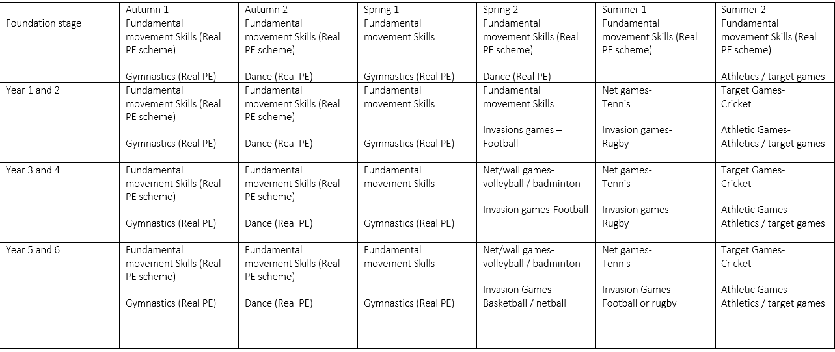

**The importance of vocabulary**

Teachers use questioning, and provide opportunities for discussion and investigation to support the development of specific PE language and vocabulary, which is explicitly taught and modelled by teachers in every lesson. Key scientific abstract terms and language (such heart rate, attack, defend, core, balance, evade, space are revisited frequently, and specifically indicated within the short-term planning sequences.

**Oracy within the curriculum**

At Highfield Farm primary School we use oracy as a means to ‘learn to talk’ and ‘talk to learn’. Our staff use strategies to promote talk in lessons which aims at not only developing the children’s ability to talk effectively for a variety of purpose, but also as a means to develop their understanding of the content being taught. Where possible, we create opportunities for the children to use talk to support their own and others learning. This may be critiquing their own skill development or commenting on a team’s strategy in a game scenario.

The REAL PE scheme is designed to foster of culture where learning behaviours are developed. This is deliberate. The learning behaviors include a social aspect, meaning that many of the learning activities and skills allow children to lead others, improve others, organize and guide others, work with others, help and encourage others understand others and play with others with help. The repeated exposure to these learning behaviors underpins works in tandem with the development of the FMS. Our work on oracy will enable us to increase the visibility and importance of discussion, collaboration and talk which are crucial for supporting children within PE.

**EYFS**

The Early Years Foundation Stage (EYFS) at Highfield Farm Primary School plays a pivotal role in laying the groundwork for a child's Physical Education understanding. Through a play based and exploratory approach, EYFS introduces young learners to foundational physical development concepts, setting the stage for continued exploration in primary education. Activities in EYFS involve hands-on movement of gross and fine motor skills

As children progress from EYFS to KS1 and KS2, the foundational knowledge gained during the early years at the school serves as a platform for deeper competence in physical activity. Concepts like the

**Impact**

The impact of our PE curriculum is measured in a variety of ways: questioning during lesson time, evaluating children’s physical movement, ability to play in competitive games and apply strategy, listening to child-led discussion, interviewing pupils across the school about their learning.

By end of the PE curriculum at Highfield Farm Primary School, our children will:

• Have a growing knowledge of the importance of being physically healthy as as an important feature of growing up

• Have a wider vocabulary of Physical Education and sporting specific terms.

• Aspire to participate in physical activity either for competition or own health benefits and participation

• Know that they can use their voice to express themselves and their opinions.

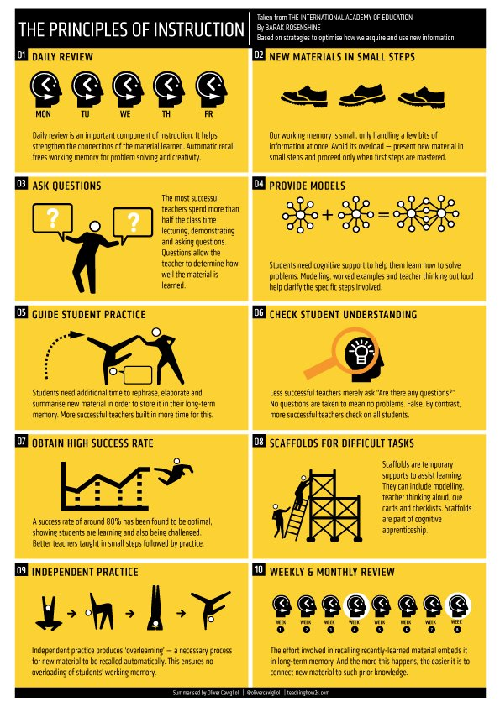**Appendix**