|  |
| --- |
| **HIGHFIELD FARM PRIMARY SCHOOL**  **MFL Policy**  **Date of Policy approval _____________**  **Date of Policy review _______________** |

“One language sets you in a corridor for life. Two languages open every door along the way.”

**– Frank Smith**

In the knowledge society of the 21st century, language and competence and intercultural understanding are not optional extras, they are an essential part of being a citizen. Language skills are also vital in improving understanding between people here and in the wider world, also in supporting global citizenship by breaking down barriers of ignorance and suspicion between nations. Learning other languages gives us insight into the people, culture and traditions of other countries, which helps us to understand our own language and culture.' (DfE)

At Highfield Farm Primary School, we recognise the importance of different languages and that learning a modern foreign language provides freedom from insularity and deepens understanding across nations. A high-quality language education should build on and foster a child’s natural curiosity in their understanding of the world. Our teaching of modern foreign language should enable a child to understand and respond to speakers, both in speech and writing. There should also be a myriad of opportunities for them to write for different purposes so that they are able to communicate effectively. We understand that language teaching in KS2 opens doors and provides a foundation for learning further of languages later in life and to increase awareness of different countries and cultures.

At Highfield Farm, we provide opportunities for learning Spanish as part of our MFL school curriculum which was developed in line with the National Curriculum.

**Intent**

The 2014 National Curriculum highlights the following aims for all children by the end of KS2:

* understand and respond to spoken and written language from a variety of authentic sources
* speak with increasing confidence, fluency and spontaneity, finding ways of communicating what they want to say, including through discussion and asking questions, and continually improving the accuracy of their pronunciation and intonation
* can write at varying length, for different purposes and audiences, using the variety of grammatical structures that they have learnt
* discover and develop an appreciation of a range of writing in the language studied.

A high-quality languages education should foster children’s curiosity and deepen their understanding of the world. At Highfield Farm Primary School, we are committed to ensuring that competence in another language enables children to interpret, create and exchange meaning within and across cultures. It also helps children develop skills that will open further opportunities later in life. The teaching of Spanish in KS2 provides an appropriate balance of spoken and written language and lays the foundations for further foreign language teaching at KS3.

We recognise at Highfield Farm the importance of early language acquisition for both English and modern foreign languages, which is why we have placed the subject within our ‘Specialism’ aspect of our curriculum.

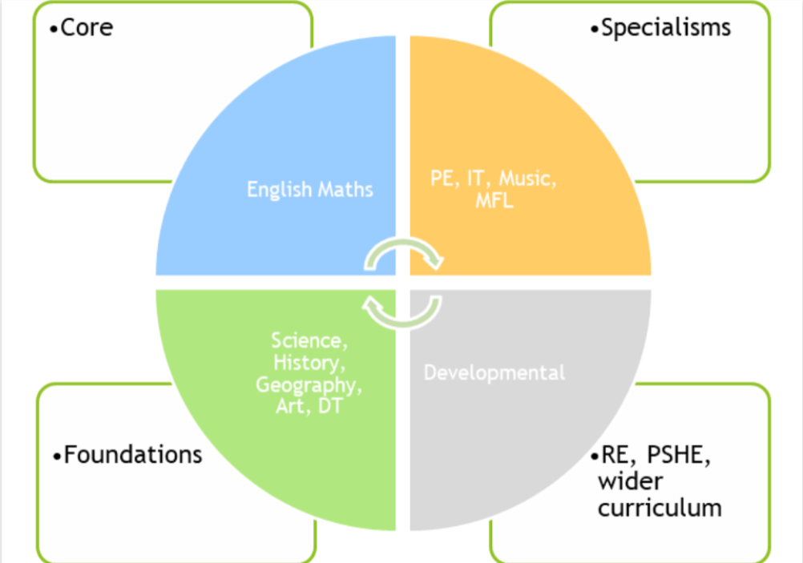

**Implementation**

Children are introduced to formal MFL lessons in KS2 and receive a weekly lesson. This enables the children to develop and build on early language acquisition skills, which facilitates their understanding of the patterns in language and how these differ, or are similar, to English. Children learn Spanish in Year 5 and Year 6. All lessons are timetabled for 30-minute slots per week with regular recall made throughout the week wherever possible. A scheme of work provided by a Languages specialist from a local Secondary School is used (rachelhawkes.com), to give the children a reflective offer of what they be provided in KS3.

Lessons across the Key Stage are designed to support the skills of listening, speaking, reading, writing and vocabulary acquisition:

* Children are taught to listen and follow attentively, joining in with songs, rhymes and, where possible, games in order for the children to develop their pronunciation of the language they are learning;
* Links are to be made with the local secondary setting, so that the children have acquired the necessary skills they require by the end of KS2 and are KS3 ready;
* Children are encouraged to develop an appreciation for both the language and culture they are learning in their cohorts through listening to songs, poetry and stories;
* The sessions are to be delivered through BBC Bitesize in order for children to have a firm footing ready for year 6. In year 6, the primary secondary school setting is working with schools within the local area to develop a program designed to ensure all children have a good footing in their language education.

**Monitoring and Review**

A modern foreign languages coordinator within the school setting monitors the teaching of learning of both French and Spanish within the school. The coordinator liaises with the local secondary school (Wath Academy) where most of our children tend to enrol so that they are aware of our children’s MFL experience and that our curriculum fully enables KS3 readiness.

**Equal Opportunities**

At Highfield Farm Primary, we are committed to promoting equal opportunities irrespective of socio-economic background, gender, disability and ethnicity in all areas of the curriculum. We believe all children should have access to and participation in the learning of languages and to be supported in this process.

**Oracy within the curriculum**

At Highfield Farm Primary School. we use oracy as a means to ‘learn to talk’ and ‘talk to learn’. Our staff use strategies to promote talk in lessons which aims at not only developing the children’s ability to talk effectively for a variety of purpose, but also as a means to develop their understanding of the content being taught.

**Inclusion**

*The SEND Code of Practice states that all children should have access to:*

*‘****high quality******teaching****that is****differentiated****and****personalised****, which will meet the individual needs of the majority of children and young people.****Some children and young people need educational provision that is additional to or different from this****. This is special educational provision under Section 21 of the Children and Families Act 2014. Schools and colleges must use their best endeavours to ensure that such provision is made for those who need it. Special educational provision is underpinned by high quality teaching and is compromised by anything less.*’

See our SEND policy for further information.  We support every pupil to succeed through scaffolding, explicit instruction, use of technology, flexible grouping and small steps of learning, as required and depending on their individual needs, and as recommended by the Education Endowment Foundation (EEF).

**Impact**

The impact of out MFL curriculum is measured in different ways. The children are assessed by the teacher and also carry out self-assessments to see and monitor the progress that they are making in the language. This is done informally during the lessons to inform future planning. We assess:

* Listening
* speaking
* talking to somebody
* reading
* writing
* intercultural understanding

Children are assessed on an ongoing basis by the class teacher. At the end of each term teachers will assess children against the POS in order to inform future planning. On an annual basis, we report progress to parents as part of our end of year report.

By the end of the MFL curriculum at Highfield Farm Primary, our children will:

* Have deeper and meaningful understanding of both French and Spanish as languages;
* Have a deeper and meaningful understanding of both cultures;
* Have a wider understanding of the basic principles of both languages, with Spanish as a focus;
* Aspire to become fluent speakers in the future;
* Be able to respond and ask simple questions in both French and Spanish;
* Be able to explore the patterns and signs of language;
* Read and show understanding of simple sentences and phrases;
* Describe people, places, things and actions orally and in writing.

**Appendix**